Draft Recording Form for Safeguarding Concerns
Staff, volunteers and regular visitors are required to complete this form and pass it to [Enter name of DSL] if they have a safeguarding concern about a child in our school.
Information Required | Enter Information Here
Full name of child
Date of birth
Class/tutor group/form group
Your name and position in the school
Nature of concern/disclosure
Please include where you were when the child made a disclosure, what you saw, who else was there, what did the child say or do and what you said.
[Ensure that if there is an injury this is recorded (size and shape) and a body map is completed]
[Make it clear if you have a raised a concern about a similar issue previously]
Time & date of incident:
Name and position of the person you passing this information to?
Your Signature
Time and date form completed
Time form received by DSL
Action Taken by DSL
Referral made to Attendance Lead [yes/no, date and time]
Referral made to police [yes/no, date and time]
Referral made to Just One Norfolk [yes/no, date and time]
Referral made to CADS [yes/no, date and time]
Referral made to PSA [yes/no, date and time]
Referral made to Community & Partnerships [yes/no, date and time]
Referral Made to Other Agency [yes/no, date and time, name of organisation]
Parents Informed [yes/no, date and time]
Feedback given to pastoral team
[yes/no, date and time]
Feedback given to teacher
[yes/no, date and time]
Feedback given to child
[yes/no, date and time]
Feedback given to person who recorded disclosure
[yes/no, date and time]
Further Action Agreed
Full Name of DSL
Signature of DSL
Date of Signature

Body Map
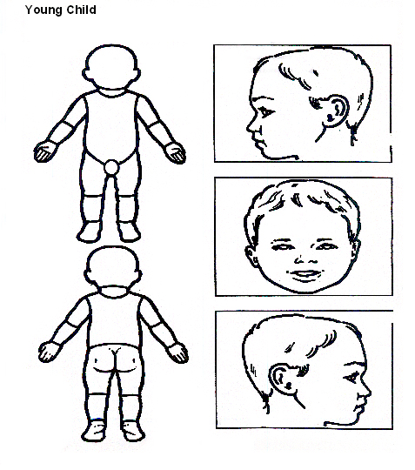Indicate clearly where the injury was seen and attach this to the referral form

Body Map
Older Child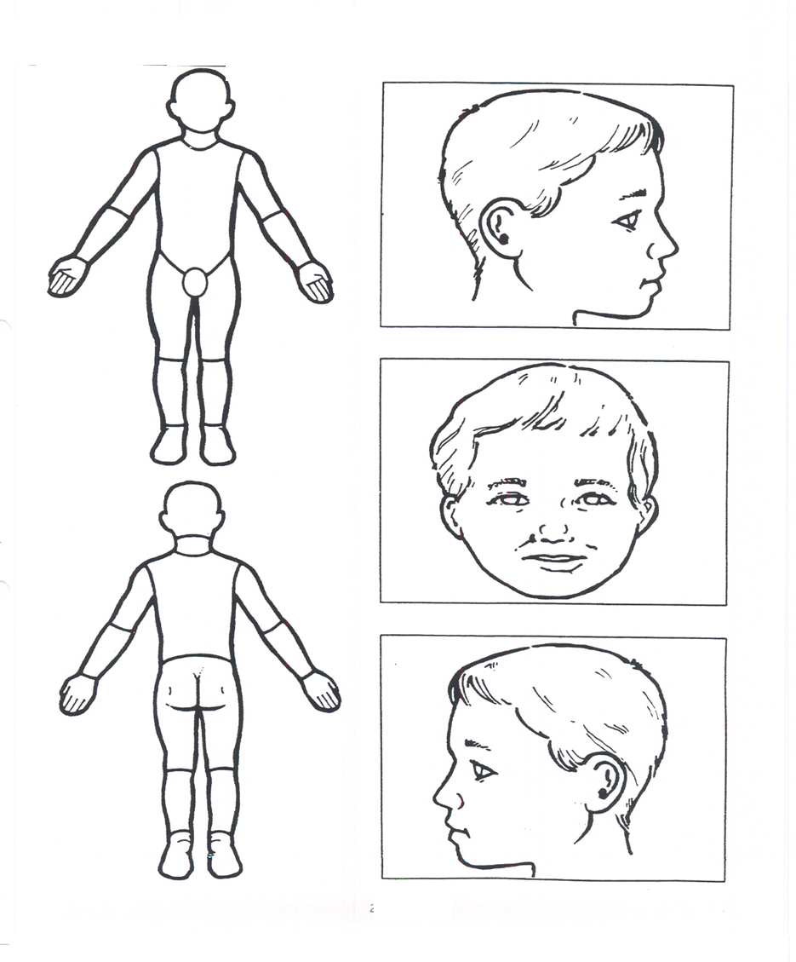
Indicate clearly where the injury was seen and attach this to the referral form.

