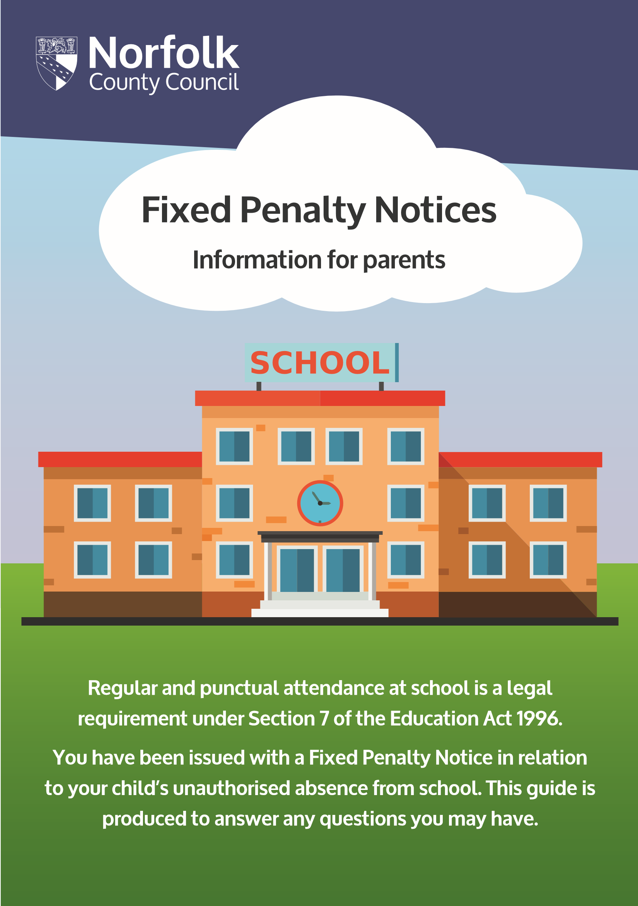
What is a Fixed Penalty Notice?
The Anti-Social Behaviour Act 2003 introduced legislation that made provision for a Local Authority to issue Fixed Penalty Notices. These notices require a fine to be paid by parents of pupils who have unauthorised absence from school. The fine will discharge the potential liability to be prosecuted
A separate Penalty Notice will be issued to Each parent for Each child who has unauthorised absence.
Who makes the decision to Issue a Fixed Penalty Notice?
It is the Headteacher/Governor following Government Guidance who makes the decision. The Local Authority administers the notices on behalf of the Schools
In what circumstances will Fixed Penalty Notices be issued?
In Norfolk, penalty notices are issued in accordance with the Norfolk Local Protocol. Your child’s school will have provided you with information regarding the criteria in which they will refer cases of unauthorised absence to the Local Authority for issuing of a Fixed Penalty.
In all cases a penalty notice can only be issued if the pupil has accrued at least 9 sessions (4.5 school days) of unauthorised absence within the previous 6 school weeks.
What is the cost of a Penalty Notice?
If a Fixed Penalty Notice is issued the penalty is £60 when the payment is made within 21 days or £120 when the payment is made after 21 days but prior to 28 days. Failure to pay within 28 days will result in a summons to appear before the Magistrates’ Court on the grounds that you have failed to secure your child’s regular attendance at school.
Frequently asked questions:
Can I dispute the Fixed Penalty Notice?
Only a headteacher can authorise absence from school. If there are other exceptional and compelling circumstances of which the school were not aware of, you can make a representation to the headteacher. If the school maintain the absence was unauthorised, the Penalty Notice will stand.
There is no right to appeal against a Fixed Penalty Notice, but you may choose not to pay and make your representations in the Magistrates’ Court. You should be aware that should the court find you guilty of the offence of irregular school attendance, they can impose a higher punishment upon conviction. The court may also charge you with court costs.
I do not live with the child or I am a stepparent, can I still be fined?
Yes, Section 576 Education Act 1996 defines ‘parent’ as:
- any natural parent, whether married or not
- any parent who, although not a natural parent, has parental responsibility as defined in the Children Act (1989) for a child or young person
- any person who, although not a natural parent, has care of a child or young person
Why do some schools authorise absence and another does not?
The headteacher is the only person who can authorise absence. Headteachers are only able to authorise absence requests for exceptional reasons and each circumstance will be individual and likely to receive a different response.
My child has never had unauthorised absence before, why have I been fined?
The notice has been issued based on the referral criteria; which meets the threshold for irregular attendance at school. School attendance is crucial to children and any absence will have an impact upon your child’s education. Your child’s headteacher will have based their decision on whether the absence request was exceptional rather than based on your child’s attendance level.
I cannot afford to pay the fine, can I pay in instalments?
The Local Authority has issued the Fixed Penalty Notice in accordance within the timeframe as laid out in law. The Local Authority is unable to assist with instalment payments. If you cannot afford to pay the only place where this can be resolved is in the Magistrates’ Court following non-payment. The Magistrates’ Court can make collection orders (paying by instalments) and will take your financial circumstances into account.
Can the Local Authority withdraw the Penalty Notice?
The only grounds in which a Penalty Notice can be withdrawn are:
- It ought not to have been issued i.e. where it has been issued outside of the terms of the Local Protocol or where no offence has been committed.
- It has been issued to the wrong person
- It contains material errors
- The Fixed Penalty Notice remains unpaid and the Local Authority opt not to proceed with a prosecution under Education Act 1996 Section 444 (1).
If your question has not been answered here, please contact The Attendance Team on 01603 223 681 or email csattendance@norfolk.gov.uk
Details on how to pay your fixed penalty notice is contained within the notice you have received.

© Norfolk County Council 2021

