The Staff Module is a means to record –
- staff that work directly with children
- leads and individuals who run or support groups (eg. Parent and Toddler)
- committee members / supernumerary staff
- qualifications
- special requirements
- main contact (Being 2 / Finance)

This data will be held for training purposes, communication, and workforce development.

To access the module, it will be necessary to have existing access to the online Provider Portal.

The link to the online service is – www.norfolk.gov.uk/eyproviderportal

Once you have logged on to the online system, click STAFF

Once selected, a list of staff members will be displayed. This list will consist of all active staff/contact records currently held by the Local Authority.
- Consent must be sought BEFORE an individual’s information can be added to your staff records.
- It is not necessary to supply information which is not mandatory unless it is required for communication or training purposes.
- It will not be possible to book a place on a course, event, or briefing session if the delegate is not listed in the module.
- The spelling of a name in a record will be used when certificates are issued.
- Removing (deleting) a record from the list DOES NOT remove their record from a newsletter subscription list or access to the Portal.

It is recommended that the details of staff and colleagues already listed are processed as follows –

① Delete (end date) all records where the person is no longer associated/employed
② Update records for all persons listed that remain associated/employed
③ Add new records
① To DELETE a record

Select EDIT for the record to be deleted

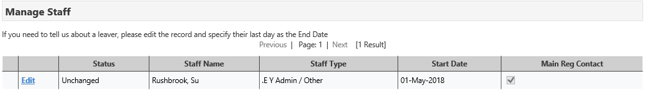
Select the Staff Main Details tab

Insert an END DATE to the record (this is the last date of employment / association)
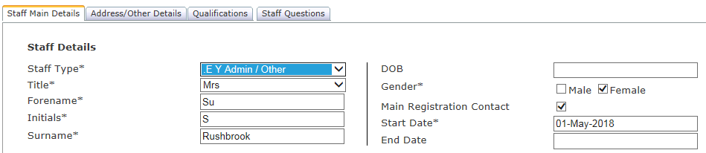

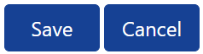
Click SAVE
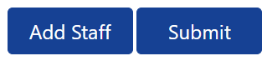
Click SUBMIT when all records have been updated

The status will advise the progress of the submitted updates

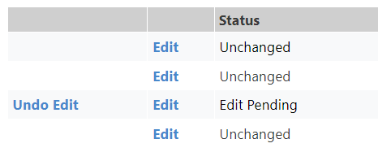

② To AMEND a record
Select EDIT for the record to be amended

In turn select each tab to update the details held

TAB: Staff Main Details

Fields:
- * denotes those that are mandatory
- Staff Type – please select one of the following
- . ECFS Contact  - . Parent & Toddler Contact  - .E Y Admin / Other  - .E Y Childminder  - .E Y Childminder Assistant  - .E Y Committee Member  - .E Y Committee Member - Chair  - .E Y Committee Member – Secretary  - .E Y Committee Member - Treasurer | - .E Y Deputy Manager  - .E Y Manager  - .E Y Practitioner  - .E Y Room / Team Lead  - Head Teacher  - Teacher
- DOB – this is NOT REQUIRED
- Main Registration Contact – must be ticked for ONLY one person
- End Date – only required to delete the record

Please tick where applicable
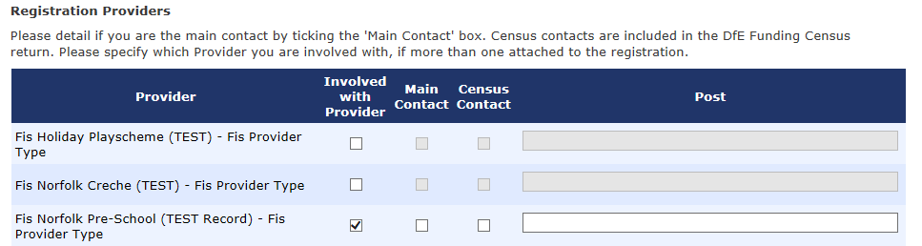
- The “Post” field will be used by the Local Authority as a record of who to contact for the purpose of funding and Being 2. The record will also be updated by the Local Authority when information is received from the provider by other sources.
- The named Being 2 contact(s) will receive data reports collated from your Being 2 eForm submissions.
- Individuals with management, training or SEND responsibilities should subscribe to our newsletters.

Add post details if the individual is responsible for or the main contact for finance/funding or Being 2

To add/amend a Post –
Please select –
- .E Y Being 2
- .E Y Finance Contact

Click box (which is open for selection)

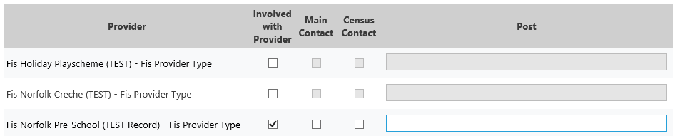

Click arrow to select and insert a post

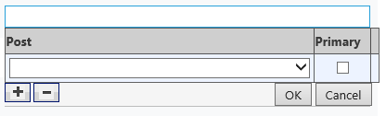

To add an additional post, click

Once all posts are listed, click OK to complete

TAB: Address/Other Details
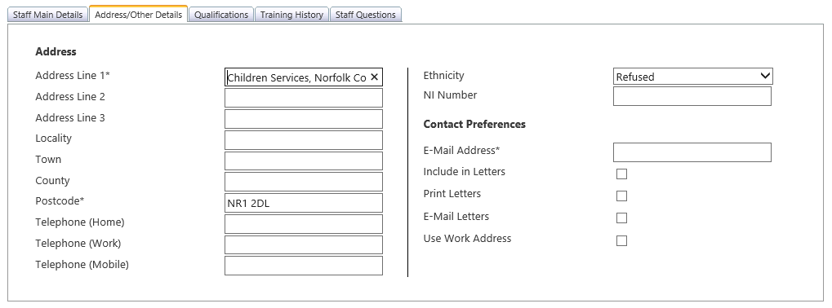

Fields:
- * denotes those that are mandatory

Please include
(these will be the details used for communication eg. training)
- Full Address
- Telephone (Work) and/or (Mobile)
- E-Mail Address (business)
- Use Work Address – PLEASE DO NOT TICK

TAB: Qualifications (this tab is not mandatory)

Click Add Qualification (new window will open)

Complete the Qualification Details (* denotes mandatory field)

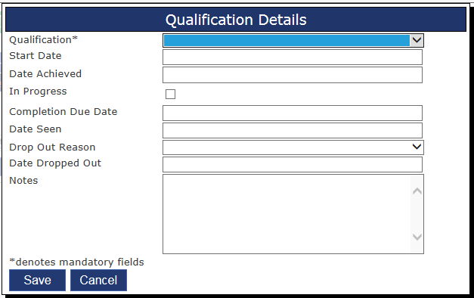

Qualification List:
- Qualification – please ONLY select one of the following
- . Apprentice
- .Early Years Professional Status
- .Early Years Professional Status - Studying Towards
- .Early Years Registration
- .Early Years Teacher Status
- .Early Years Teacher Status - Studying Towards
- .Level 2 - Full & Relevant
- .Level 2 - Studying Towards
- .Level 3 - Full & Relevant
- .Level 3 - Studying Towards
- .Level 4 - Full & Relevant
- .Level 4 - Studying Towards
- .Level 5 - Full & Relevant
- .Level 5 - Studying Towards
- .Qualified Teacher Status

It is possible to add notes if required
Click SAVE

TAB: Training History
This tab is for information only, and will provide a list of training requests for an individual. For specific details concerning the course attendance
Click VIEW

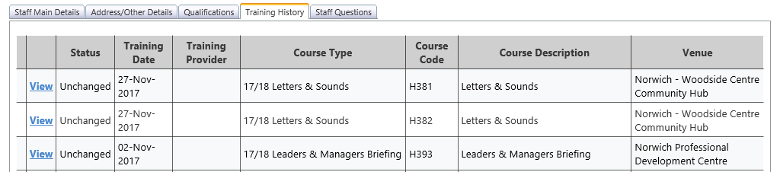

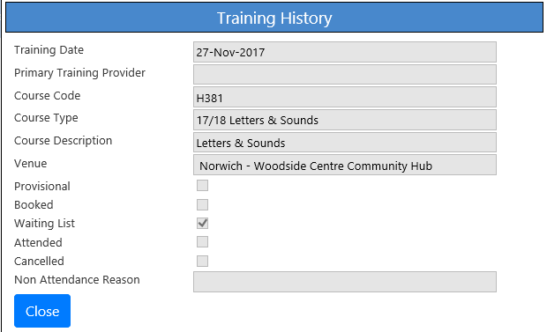

TAB: Staff Questions
This tab should be completed for any staff that have a special requirement to enable them to attend an event offered by the Early Years Service.

Tick YES, if applicable.
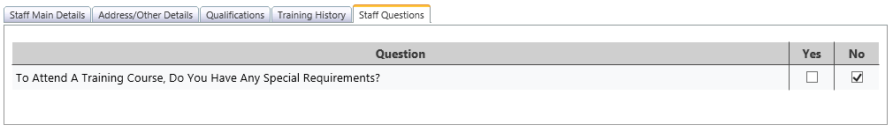

Click SAVE
Click SUBMIT when all records have been updated

The status will advise the progress of the submitted updates

③ Add new records
Click ADD STAFF

In turn select each tab to update the details held

(refer to ② To AMEND a record)

Click SAVE
Click SUBMIT when all records have been updated

The status will advise the progress of the submitted updates

Top Tips!

- Subscribe to our newsletters, so that you are kept up to date about the provider portal and any deadlines to review / submit data.
- Housekeep your staff records termly to retain accuracy.
- Seek consent with everyone before sharing their information and issue privacy notices as needed for GDPR compliance.
- For system security, review termly access to the portal and use the PORTAL – Userid eForm to add, amend or delete an individual’s access.

Need Help!

Call the Advice Line on 01603 222300 or email
earlyyearsandchildcare@norfolk.gov.uk

