Funding Claims for Early Education

Contents
- Steps 1 and 2: Provider Details
- Steps 3 and 4: Funding Claims
- Step 5: Data Protection
- Step 6: Guidance and Support

This guidance is issued by the Early Years Finance team following the completion of the Funding Agreement process and the return of the signed Agreement to the Provider.

For further enquiries, please either –

 earlyyearsfinance@norfolk.gov.uk
or
 01603 222300 (Option 2)

Now that your Funding Agreement has been agreed, there are several steps to be completed to enable you to claim the funding on behalf of families.

① Provide your bank details to enable payments to be processed
② Provide qualification certificate details to ascertain if a supplement is payable
③ Check Provider Portal access to claim funding and determine training requirements
④ Ascertain an estimate for early education or actuals
⑤ Data Protection
⑥ Guidance and Support

Steps 1 and 2
Please return the Provider Funding & Supplement Update Form as soon as possible to enable us to record your payment and supplement details and progress any payments for you

Step 3 and 4
Funding is claimed via an online service called Norfolk Education Online (NEO). The weblink to the provider portal / professional home page is – www.norfolk.gov.uk/eyproviderportal

Please call the Early Years finance team on 01603 222300 Option 2 to discuss your funding claim for the current claim period, and the actions that will be required. Access to the funding module will be checked to ensure it is possible to submit your first claim, and training availability will be given at the same time.

It is recommended that you book a place on a training course offered by the team, or it is possible to request a bespoke session. The training sessions are offered via Teams and cover each module within the portal.

Please search for training opportunities via the COURSE module on the portal.

There is also a  demo for the funding module https://youtu.be/lz6zfUf9iA8

Usernames and passwords should not be shared, additional id’s can be sought by completing a User ID request form via the FORMS module. If you need support with this, please contact Family Information – fis@norfolk.gov.uk.

The Early Years finance team will also check that all the various forms have been completed, and whether you have signed up to the tax-free childcare scheme as a payment method for families.

To claim funding, there is a requirement to complete certain actions by a specified deadline.

These deadlines are shared in the finance half termly newsletter and can also be found via the portal or the online calendar.

Estimates
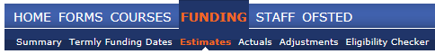
These are a “best guess” of the TOTAL hours that will be claimed over the course of the next claim period for EACH funding type. These are submitted (collected) at the end of each claim period in readiness for the next and will be used to determine your initial monthly payments.

If the deadline for the Estimate submission has passed, please submit your Actuals.

Actuals
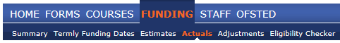
These are the details of the children that funding will be claimed having obtained consent from the family. This information is populated using the information collected on the parent / carer claim form.

The completion of the claim form is mandatory each claim period. Parents and carers must acknowledge the declaration by ticking every statement and signing the document to claim 2-year-old or 3 and 4-year-old funding. Please ensure the correct sections are completed for each claim.

Where necessary, it is acceptable to support parent/carers to fill out the form to claim the funding. However, it is not acceptable to complete the form on their behalf and expect them to simply sign the form. All parents/carers must have a clear understanding of what they have signed and what will be claimed on their behalf.

Early Education funding cannot be claimed without a signed form in place as consent MUST be obtained to share information with the Local Authority. Failure to meet this requirement will mean that funding will be recovered if we become aware of non-compliance.

Claim forms must be securely stored for a period of 6 years plus current.

The parent/carer booklet must be shared with all new families prior to them making their first funding claim. The aim of the booklet is to communicate how funding is offered in Norfolk, how/when it can/must be claimed and what they should expect.

Number of hours to claim for each child:
The Local Authority will recommend a maximum number of hours that can be claimed for a child. This recommendation will depend on the child's date of birth (cycle of eligibility) and whether the entitlement is taken term time only or is stretched.

The actual number of hours to claim will be based on the child's pattern of attendance.

There are a number of Excel Calculators to help you in this task.
- Calculator for Parent Claim Form
- Calculator for Estimates and Actuals
- Annual Calculator (based on date of birth) – Summer / Autumn / Spring

It is recommended that you refer to our newsletter for more information about the current claim period and how to calculate the number of hours to be claimed.

Child Record:
The child record on the portal is split in to five sections.

The Parent/Carer Details tab is only required where funding will be claimed for the extended hours (30 hours) for 3-and 4-year-olds or Early Years Pupil Premium.

The Notes Tab is used to advise of any anomalies relating to the funding.
Examples –
- Funding is shared with another provider. Their claim should be 200 hours
- Weekly funded hours increased from 4th June
- Pattern of attendance includes 2 additional sessions

The tab must also be used to record other Criteria Met for 2-year-old funding or Early Years Pupil Premium
- Looked After by the LA
- Receives DLA
- Left Care through an adoption, a special guardianship order or a child arrangement order
- EHCP

PLEASE NOTE – If the NCC Reference Number cannot be matched with a NEO account record, we will assume that the child is not eligible, and the record will be deleted.

3 and 4-Year-Old Funding – Extended Hours (30 hours): 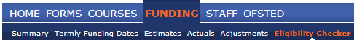
Often these additional hours are shared with two or more providers, so that families can access their full entitlement. Even if you are only offering the universal hours to families, parents are required to nominate where the funding will be claimed. It is therefore important that parental consent has been sought as part of your registration process (or contract change), to enable a check that the eligibility code is valid. Once the code is confirmed as valid the additional hours can be offered as part of your childcare arrangement with the family.

PLEASE NOTE – Eligibility Code Checks for 30 hours should be completed as soon as possible.

Funding can only start at certain times and will be dependent on a child’s date of birth and where applicable when an eligibility code was applied for / re-confirmed.

Born on or between | Universal Offer  (15 hours)  Funding from: | Eligibility Code obtained for the Extended Offer | Extended Offer  (30 hours)  Funding from:
1st Apr and 31st Aug | 1st Sept | Before 1st Sept | 1st Sept
1st Apr and 31st Aug | 1st Sept | On or after 1st Sept | 1st Jan
1st Sept and 31st Dec | 1st Jan | Before 1st Jan | 1st Jan
1st Sept and 31st Dec | 1st Jan | On or after 1st Jan | 1st Apr
1st Jan and 31st Mar | 1st April | Before 1st Apr | 1st Apr
1st Jan and 31st Mar | 1st April | On or after 1st Apr | 1st Sept

Step 5
General Data Protection Regulations:
The GDPR (General Data Protection Regulations) came into effect on 25 May 2018, replacing the Data Protection Act 1998.

It is important that you are aware of your own obligations and how to comply. Visit the Information Commissioner's Office website to check whether you are required to register and ensure you are up to date with data legislation.

Individuals have –
- the right to know the types of data being held
- why it is being held, and
- to whom it may be communicated

The most common way to provide this information to individuals is in a Privacy Notice. A Privacy Notice for funding should be issued to all new parents and carers to explain how the data is being used. It is not necessary to issue a notice on an annual basis as long as all parents and carers (and staff) are made aware of the notice(s), and they are readily available electronically or in paper format.

The Department of Education (DfE) has drafted template privacy notices that your provision may like to use, however, they should be reviewed, amending as necessary to reflect business need and ideally include the link to the gov.uk webpage on how the DfE collects and shares data.

The GOV.UK webpage link : www.gov.uk/guidance/data-protection-how-we-collect-and-share-research-data

Email Messages:
From time to time it may be necessary to email child details or other sensitive data to the Local Authority. It is important that these messages are sent securely and where applicable the child cannot be easily identified. If necessary, please request a “secure email message” which you can use to respond/provide information.

For further guidance on secure emails, please click here.

Step 6
There are several ways to seek support and find information concerning Early Years –

Early Years Newsletters
Remember to sign up our Early Years newsletters to stay up to date with what's happening in Norfolk.

Click on the link to subscribe –
https://www.schools.norfolk.gov.uk/early-learning-and-childcare/enewsletters

Norfolk Education Online:
The is a wealth of guidance and resources on the portal for you to use. You may wish to use some of the family resources for your next newsletter. The weblink to the home page is – www.norfolk.gov.uk/neo

Early Years Payments:
Payments for Early Education funding are paid monthly. Please click here for the dates and/or subscribe to Early Years Online Calendar.

Early Years Online Calendar:
There is a calendar which is available online which details events and deadlines. It is also possible to subscribe, which means it is accessible on a mobile device (phone / tablet).

To subscribe, click the link online and follow the instructions.

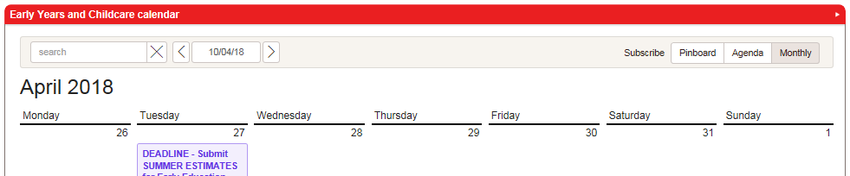

Be Prepared!
It is recommended that you familiarise yourself with the documentation on our webpages and provider portal as part of your preparation to claim funding.

For funding queries please use 

Funding  and Portal  Overview  and Q&A  Sessions  (via Teams) | Each term sessions are offered to all providers and give an overview of all funding opportunities available to providers.  - Early Education  - SEND Additional Support  - Early Years Panel Funding  Places can be booked via the course module of the portal
Norfolk Education Online (NEO) | Provider Home Page > Quicklinks  www.norfolk.gov.uk/eyproviderportal  - Quicklinks – Early education funding  Family Home Page > Resources  www.norfolk.gov.uk/neo
Advice Line | 01603 222300  - Option 2 – Funding  - Option 3 – All other queries
Email | EARLY YEARS FINANCE TEAM  - earlyyearsfinance@norfolk.gov.uk  EARLY YEARS SERVICE  - earlyyearsandchildcare@norfolk.gov.uk
Web Pages | LOCAL  - www.schools.norfolk.gov.uk/early-learning-and-childcare  - www.norfolk.gov.uk/children-and-families/send-local-offer  NATIONAL  - www.gov.uk/government/policies/childcare-and-early-education

These is also a national website for providers and parents/carers –
 | FOR PROVIDERS  https://www.childcarechoices.gov.uk/providers/  FOR PARENTS / CARERS  https://www.childcarechoices.gov.uk/

and finally …………….

If in doubt, please do not hesitate to call the Advice Line to seek support

01603 222300

