GUIDANCE
New
Provider

v. May-22

Contents
- Advice Line and Support
- Norfolk Education Online (NEO)
- Joining the Norfolk Community Directory
- Help families pay for their childcare
- Quality Improvement Support
- Early Education Entitlement for
2-, 3- and 4-year-olds
- Local Authority Funding Agreement
- The General Data Protection Regulations (GDPR)
- The Early Years Foundation Stage (EYFS)
- Keeping children safe in early education and childcare
- Early Years Pupil Premium
- Being 2: The Shared Review
- Training and professional qualifications
- Transition
- EYFS assessment
- Marketing resources
- Ofsted inspections of early years and childcare providers
- The Teams
  - The Achievement and Early Years Service
  - Family Information
  - Early Years Finance
- News and Information

Welcome to the Learning and Achievement Service
Dear New Provider,
Congratulations on becoming a registered early education and childcare provider. We hope that you have a successful and fulfilling career ahead of you.

The Learning and Achievement Service is committed to working in partnership with you to ensure that the children in your setting receive the highest quality early education and care, make good progress throughout the Early Years Foundation Stage (EYFS) and are well prepared for school.

This welcome letter and guidance are designed to give you all the information that you need from the start of your new career. It introduces you to a range of practical resources and information that can support you as a new provider to achieve and maintain best practice and quality in providing early education and childcare.

Kind regards,

Jo-anne Lamb
Senior Adviser, Early Years Learning
The Learning and Achievement Service

Your guide to information and support


- Advice Line and Support
Information about Early Years in Norfolk can be found on our website at
www.schools.norfolk.gov.uk/earlyyearsandchildcare.

Here you will find professional information, resources, updates on Early Years and Childcare in Norfolk, including finance and funding information and training courses, alternatively please call the Advice Line.

Early Years Finance Team  (Funding) | 01603 222300 (Option 2)  earlyyearsfinance@norfolk.gov.uk
Early Years Achievement Team  (Improvement, Inclusion & Training) | 01603 222300 (Option 3)  earlyyearsandchildcare@norfolk.gov.uk

Support can also be sought from the Family Information team.

Family Information  (Advice to Parents and Providers) | 01603 223501  fis@norfolk.gov.uk

- Norfolk Education Online (NEO)
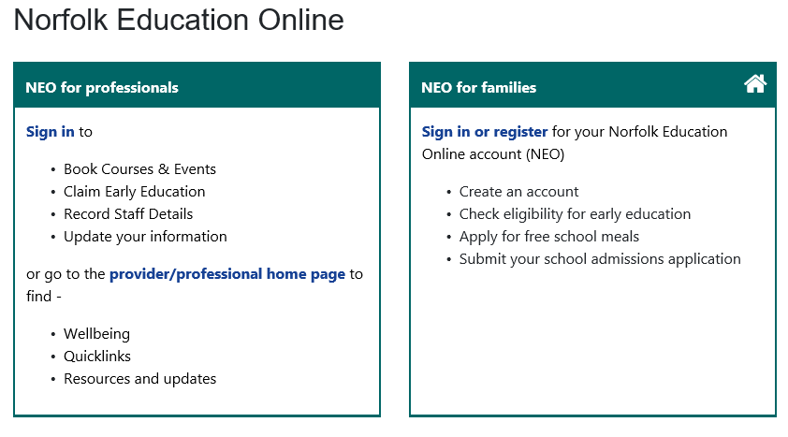
NEO is used by providers and families. There are resource pages sharing information about early years. Parent and carers will be required to open an account to check eligibility for the 2-year-old funding entitlement, check the status of their 30-hour eligibility code, apply for free school meals, and school admissions. For providers it is a source to obtain information about early years. A username is required to access the provider portal. For full access, please call Family Information so that an account can be set up.

Full access will be required if you plan to –
  - Claim early education funding
  - Book courses and events

- Joining the Norfolk Community Directory www.norfolk.gov.uk/norfolkdirectory
Once you complete the Update Details Form with Consent on the portal (available in the FORMS module), we can publish your business details on the Norfolk directory if your consent is given. This is the place that parents, carers, and professionals can find an up-to-date public list of all Ofsted registered early education and childcare providers in Norfolk. There is no charge to include your details and it will help promote your business and vacancies. If you need support to access the system or have not received your account details, please contact Family Information.

- Help families to pay for their childcare
Tax-Free childcare supports working families with their childcare cost. When parents’ sign up, they will receive an extra £2 (up to a maximum) for every £8 they pay in. To help your families benefit, please sign up to accept this method
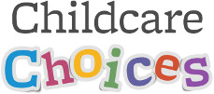
of payment.

For more information and to sign up visit
https://www.childcarechoices.gov.uk/providers/

- Quality Improvement Support
Flexible, quality assured support, advice and guidance is available and delivered by staff with specialist knowledge and understanding of all aspects of early years and childcare.

The information, resources, training and much more that we offer is aimed at helping you develop best practice in your setting.

The Service also provides a telephone Advice Line, fortnightly newsletter and termly briefings which aim to keep providers up to date with and debate national and local changes. In some cases, there may be a charge for support.

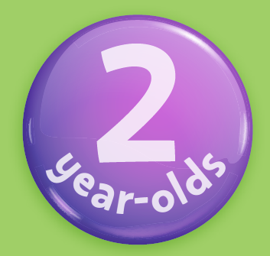

- Early Education Entitlement for 2-, 3- and 4-year-olds


The Learning and Achievement Service has a responsibility for ensuring that high quality early education and childcare provision is available and accessible to all families with young children.

Early Education is funded childcare which families can access if certain criteria is met. The criteria is set nationally by central government (Department for Education) and must be adhered to always.

The amount of funded childcare available to families will be determined by –
  - If their chosen childcare provider offers the entitlement
  - How the entitlement is offered by their chosen childcare provider
  - When their child becomes eligible
  - The pattern of attendance
  - If the maximum available has been funded

The funding is paid to providers by the Local Authority once a Funding Agreement is in place, a claim is submitted via the Provider Portal and verified that the national criteria has been met.

To make a claim on behalf of families it will be necessary to undertake certain checks to ascertain if the funding criteria has been met and issue a mandatory claim form to families for them to complete and sign. This form obtains consent for a provider to complete the eligibility checks (where applicable) and collect the personal information necessary to submit a claim and the pattern of attendance.

It is recommended that the following is read –
- Local (Norfolk)
  - Early Education Web Pages
  - Parent / Carer Booklet
This booklet must be shared with parents and carers

- National
  - Statutory Guidance for Early Education
This sets out what schools and local authorities must do to comply with the law. It must be followed by them unless there is good reason not to

  - Operational Guidance
The guide sets out:
  - what LAs should do to fulfil their statutory responsibilities
  - what early years settings should do to fulfil their agreement with the LA
  - how LAs and early years settings can support parents and children

The Entitlements –
2-year-old | 3 and 4-year-old
UNIVERSAL  Up to 570 funded hours per year for eligible children if their family has met certain criteria | UNIVERSAL  Up to 570 funded hours per year for all eligible children living in England  criteria | EXTENDED  Up to an additional 570 funded hours per year for eligible children if their family meets certain criteria and keeps their details up to date with HMRC

So that families can determine the best options for them, it is recommended that you signpost families to the Childcare Choices website https://www.childcarechoices.gov.uk/.

Early Education and Childcare for 2-year-olds entitlement

All families will need to check their eligibility via an online checker which can be accessed from their Norfolk Education Online (NEO) account. Before a place can be offered, families must share with you a copy of the confirmation email message received following completion of the simple online check. The email message will confirm eligibility plus denote a NCC eligibility code.

Key points to remember:
  - Families may be asked for additional evidence to confirm eligibility
  - Families should not obtain an eligibility code until their child is at least 21 months old
  - Looked after children (LAC) are entitled to 2-year-old funding – proof of LAC status may be asked for
  - Once a family is confirmed as eligible, the entitlement remains in place until the child is eligible for 3 and 4-year-old funding

NB: To offer the 2-year-old entitlement, you are expected to deliver a high-quality early education and childcare. You must have been graded as Good or Outstanding at your last Ofsted Inspection or are awaiting your first.

Early Education and Childcare for 3 and 4-year-olds entitlement
All families will need to confirm their child’s date of birth to access the funding.

Please remember to signpost families to the Childcare Choices website https://www.childcarechoices.gov.uk/ to enable them to find out more about the entitlements and help to pay for childcare.

To access the EXTENDED entitlement eligible families must create an online account with HMRC to obtain a code to enable them to access the additional funding.

Obtaining the code and their child’s date of birth (DOB) will determine when a family can commence claiming the extended offer

Apply for Code By | Start Claiming Extended Offer if child is within DOB range for the claim period
31 August | 1 September
31 December | 1 January
31 March | 1 April

Once the code is obtained (an 11-digit code), families must provide this, together with their details to their chosen provider.

The code must be checked for validity by you and the Local Authority each claim period. Parents must re-confirm their details with HMRC every 90 days otherwise the funding will cease at the end of a grace period.

Parents must be reminded to re-validate their details with HMRC, so that their code remains in date, and does not affect their ability to claim. It is not possible for the Local Authority to override a code which has become out of date because the family has “missed” the opportunity to renew their details with HMRC.

REMEMBER: When families can access their child’s funded extended entitlement, will be determined by the child’s date of birth and when they applied for a code / re-confirmed their details with HMRC.

30 hour funded early education for foster carers
Foster carers will be able to apply to receive the 30 hours entitlement for children in their care for the first time from September 2018. Parents can seek information from their designated social worker.

Please click here for further information Early years entitlements: operational guidance

Offering the entitlement
Pattern of Attendance
The entitlements can be offered term time or all year round to families.

Term Time | All Year Round
15 funded hours per week  for 38 weeks of the year | This is known as a “stretched offer”, which means less funded hours per week over more weeks of the year  eg. 12 funded hours per week for 47.5 weeks

The offer / pattern of attendance is determined by the provider and will define how families can claim the entitlement. To enable children to access regular, high-quality provision, whilst maximising flexibility for parents and ensuring a degree of stability for providers, providers are encouraged where possible to offer flexible packages subject to the following national standards –

  - no session to be longer than 10 hours
  - no session minimum length (subject to the requirements of registration on the Ofsted Early Years Register)
  - not before 6.00am or after 8.00pm
  - a maximum of two sites in a single day

Families can opt to access their child’s entitlement from more than one provider and choose where to claim the different funding available. Providers cannot place conditions on families for them to be able to access the entitlement.

The cycle of eligibility
When families can access their child’s funding universal entitlement will be determined by the child’s date of birth.

DOB: 1 Apr – 31 Aug | DOB: 1 Sept – 31 Dec | DOB: 1 Jan – 31 Mar
1st claim from: 1 September | 1st claim from: 1 January | 1st claim from: 1 April

Cycle of Eligibility: | Claim Period 1  (Term after their 2nd, 3^{rd,} or 4th birthday) | Claim Period 2 | Claim Period 3
Cycle of Eligibility: | 1st Claim | 2nd Claim | 3rd Claim
Cycle of Eligibility: | ⇦ ⇦ ⇦ ⇦ ⇦ ⇦ 0 – 570 hours ⇨ ⇨ ⇨ ⇨ ⇨ ⇨

The Local Authority will pro-rata the funded hours across the cycle and recommend an amount each claim period. A pattern of attendance may mean these hours must be increased or decreased, which is acceptable, provided the national standards are met.

Hours not funded by the Local Authority should be charged in accordance with your Charging Policy.

Briefing sessions
Each term we offer briefing sessions to support all providers new to claiming Early Education and/or SEND funding.

Dates and venue details can be found via our website.

There is no charge to attend these sessions, but it is necessary to book a place for one of the four sessions available via the Provider Portal.

If you are unable to attend a course you must email your name, setting and details of the course to cancel your place. Failure to cancel your place may mean a non-attendance fee will be charged.

- Local Authority Funding Agreement
If you are planning to offer Early Education to families in Norfolk, you will need to sign up to the terms and conditions set out in the Funding Agreement and meet the minimum requirements as defined by the current Statutory Guidance:

  - places are delivered completely free of charge to parents
  - places are provided flexibly in a pattern which meets the needs of parents
  - that the funding provided is used properly and in accordance with any arrangements made with the Local Authority
  - that you meet the needs of children with special educational needs and/or disabilities
  - effective safeguarding and welfare of the children in your setting
  - that you actively promote fundamental British values and not promote views or theories as fact which are contrary to established scientific or historical evidence and explanations
  - you take measures identified in a report from Ofsted to improve the overall effectiveness of the provision [see A4.23] necessary for the effective administration of the arrangements

The Funding Agreement must be renewed annually. It is not possible to offer Early Education entitlement without an agreement in place and payments for funding cannot be paid.

A provider’s Ofsted judgement will determine which Early Education entitlements can be offered. Please refer to the Statutory Guidance or call the Early Years Finance team.

It is possible to amend your funding offer at any time by submitting a new agreement. It is also necessary to amend and submit an agreement following an Ofsted inspection and/or change to the named responsible person.

Failure to meet any condition of the Agreement or Statutory Guidance will mean that the ability to offer the entitlement to families in Norfolk will be terminated.

- The General Data Protection Regulations (GDPR)
The GDPR came into effect on 25 May 2018. It replaced the Data Protection Act 1998. It is important that you are aware of your own obligations and how to comply. Please visit the Information Commissioner’s Office website to check whether you are required to register and to ensure you are compliant/kept up to date with data legislation.

The most common way to provide information to individuals is in a Privacy Notice. A Privacy Notice for funding should be issued to all new parents and carers to explain how the data is being used. It is not necessary to issue a notice on an annual basis if all parents and carers (and staff) are made aware of the notice(s) and they are readily available electronically or in paper format.

The Department for Education (DfE) has drafted template privacy notices that your provision may like to use, however, they should be reviewed/amended as necessary to reflect business need and ideally include the link to the gov.uk webpage on how the DfE collects and shares data.

Key points to remember:
Please ensure that
  - you maintain appropriate and current registration as data handlers with the Information Commissioner’s Office
  - comply with the requirements of the GDPR in relation to personal data
  - permission is obtained from parents/carers in relation to the holding of children’s personal data and manage data appropriately where this permission is limited or withheld
  - parents/carers are made aware of Norfolk County Council’s Privacy Notice in respect of funded children and any other children whose personal data is held on any system shared with the Local Authority
  - you support data sharing with Health and other partners as requested

For more information about the privacy of the information you are submitting, please consult our Privacy Notice or visit the GOV.UK webpage.

- The Early Years Foundation Stage (EYFS)
The Early Years Foundation Stage (EYFS) sets standards for the learning, development, and care of your child from birth to 5 years old. Browse our website for more information on EYFS topics and themes.
  - Meeting the requirements set out in the Statutory Framework for the Early Years Foundation Stage (EYFS)
  - Information and advice about early education and childcare for under fives
  - Funded early learning and childcare
  - How to identify what SEND support is required for a child and what support is available
  - Additional funding for children with SEND including the SEN Inclusion Fund and the Disability Access Fund
  - Inclusion
  - Behaviour
  - Equalities

  - Specialist Equipment for Early Years and Childcare
  - Help for providers to meet their legal obligations to make reasonable adjustments
  - Medical training for providers
  - Maintained infant and nursery schools
  - Home learning
  - Admission to reception classes

- Keeping children safe in early education and childcare
For advice on the procedures to follow if you have concerns about a child or a member of staff in your setting. Please go to –

https://www.norfolk.gov.uk/children-and-families/keeping-children-safe

You should also refer to information and guidance given on any recent safeguarding training that you have attended.

- Early Years Pupil Premium
The aim of the premium is to close the attainment gap between those that attract the funding and their peers. More information can be found on the GOV.UK webpage.

For an eligibility check, the following information MUST be supplied –
  - Parent Name
  - Parent Date of Birth
  - National Insurance Number or NASS Number

- Being 2: The Shared Review
Partnership working is at the heart of the Shared Review process. Bringing together the existing Health and Education reviews at age 27 - 30 months has the potential to give a more complete picture of a child’s progress, strengths and needs.

- Training and professional qualifications
In Norfolk we like to encourage providers to continue their professional development and knowledge. Our training team provides information and advice about working in the early years and childcare. They can assist you in recruiting and retaining staff in various ways including providing access to continuous professional development programmes and bursaries to achieve sector qualifications.

For more information, please email the team at earlyyearsandchildcare@norfolk.gov.uk

- Transition
We have created a series of leaflets on the transitions for children in Early Years.

- EYFS assessment
For information, advice and support with statutory Early Years Foundation Stage and assessment, please see the following websites and resources
- EYFS: assessment and reporting arrangements
- EYFS Handbook
- Early Years Foundation Stage Profile: exemplification materials

or email assessment@norfolk.gov.uk

- Marketing Resources
Newly registered providers receive copies of the following promotional items free of charge:

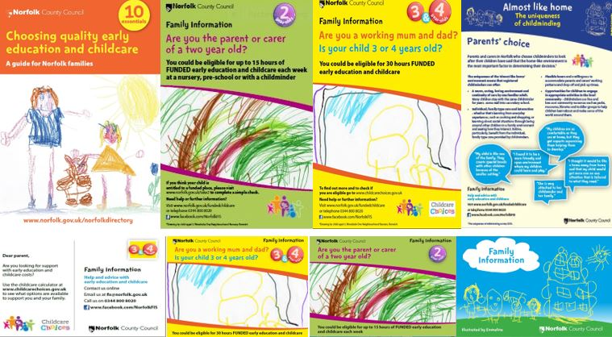

Please email Family Information for details at fis@norfolk.gov.uk

- Ofsted Inspections of early years and childcare providers
How Ofsted inspects childcare and early years, including the common inspection framework, deferring inspections, and safeguarding
For information and guidance about the inspection process and safeguarding, please visit the Ofsted website.

- The Early Years Teams
The Learning and Achievement Service
The team can offer you flexible, quality assured support, advice and guidance delivered by staff with specialist knowledge and understanding of all aspects of early years and childcare, including the Early Years Statutory Framework (EYFS), Ofsted registration and inspection, the SEND Code of Practice, training, home learning, sufficiency, funding and financial management, governance, and business planning.

You can email the team at earlyyearsandchildcare@norfolk.gov.uk

The Norfolk Early Years Staffroom
The Norfolk Early Years Staffroom is a virtual online Facebook group through which Ofsted registered early education and childcare professionals can share their experiences, best practice, and seek support related to early years practice. The group is managed and monitored by the Norfolk Early Years Achievement Team. If you would like to join the group or have any questions, please email eysocialmedia@norfolk.gov.uk.

Family Information
Family Information provides free and impartial information to all mums, dads, and carers of 0-19-year-olds (up to 25 with a disability or additional need). This includes information on finding and choosing early education and childcare, such as childminders, day nurseries, playgroups, pre-schools, nursery schools and nursery classes, children’s centres, out of school clubs and holiday play schemes. The Service is county wide and is part of the Learning and Achievement Service.

You can email Family Information at fis@norfolk.gov.uk

Follow them on Facebook www.facebook.com/NorfolkFIS

Visit their Facebook page for some digital snacking! You will find a wide variety of feeds, including updates on early years funding, ideas and resources about child development and childcare, and links to partner agencies and services.

Early Years Finance
The Early Years Finance team is responsible for processing all your claims for funding payments. They work closely with the Learning and Achievement Service to ensure statutory duty compliance relating to Early Education.

You can contact the team at earlyyearsfinance@norfolk.gov.uk with funding queries.

- News and Information
Subscribe to our alerts and newsletters which are regularly emailed to subscribers.

Early Years Newsletter (issued fortnightly)
Stay up to date with news, best practice ideas and funding and training opportunities.

Finance Newsletter (issued half termly)
Provides detail concerning your claims for early years funding, deadlines and any national or local updates specific to finance and funding.

Alerts (issued as required)
Issued in response to local and national updates concerning early years.

The Early Years Online Calendar
You can access the Early Years Online Calendar from your computer or mobile device to keep track of all upcoming events and tasks including:
  - Early Education payment dates
  - Events, training programme release dates, conferences
  - Deadline dates for panel and Early Education funding
  - Reminders
  - Newsletter publications
Click here to open the calendar http://csapps.norfolk.gov.uk/eycalendar/default.asp

