The Sufficiency Course Module supports the Local Authority to meet its duty to provide information to families concerning childcare and will enable a detailed collection of place numbers and vacancies on a termly basis.

This information may be shared with families to assist them in their searching for childcare. Eventually, the data will also appear on the Norfolk Community Directory.

The link to the online service is – [www.norfolk.gov.uk/eyproviderportal](http://www.norfolk.gov.uk/eyproviderportal)

Once you have logged on to the online system, click SUFFICIENCY

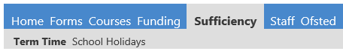

Select Year and then Term

|  |  |
| --- | --- |
|  |  |

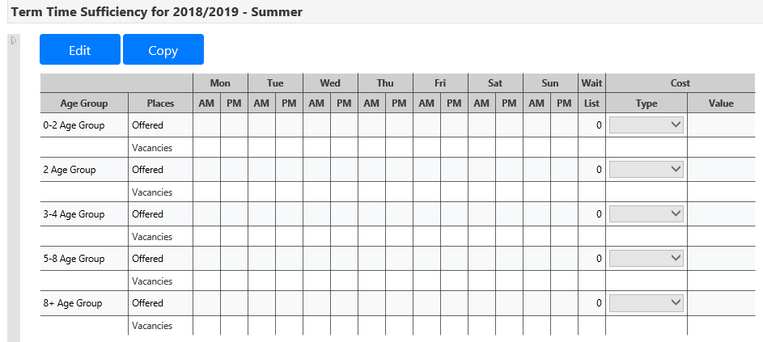

Select EDIT

If you have selected the wrong year / term, then CLICK HERE to open the menu

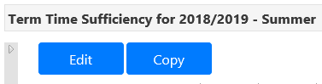

For **each** age group, please enter –

* Number of Places (Offered)
* Vacancies
* Wait List
* Cost Type
  + Per Hour
  + Per Session
* Cost Value

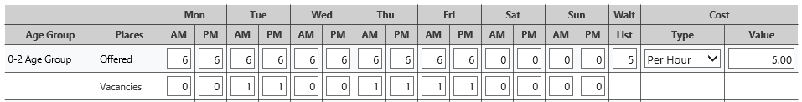



Click SAVE

A message will confirm a successful submission



If you are open for school holidays –



Click COPY

It is necessary to confirm what needs to be copied, the click SUBMIT

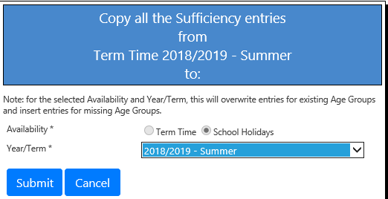

Click OK

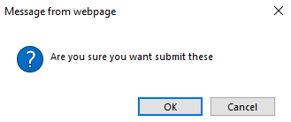

A message will confirm if successful



Click SCHOOL HOLIDAYS

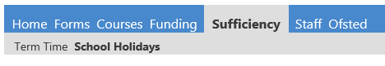



If necessary, click EDIT to amend the copied data

Adjust the data

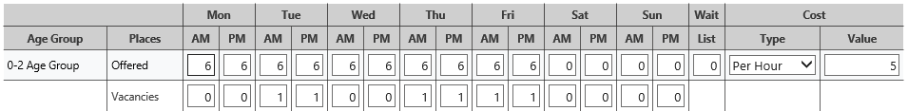



Click SAVE

Top Tips!

* Subscribe to our [newsletters](https://www.schools.norfolk.gov.uk/early-learning-and-childcare/enewsletters), so that you are kept up to date about the provider portal and any deadlines to review / submit data.
* Remember to use the copy function to transfer data
* Update your data at least termly

Need Help!

Call the Advice Line on 01603 222300

A message will confirm a successful submission



Data should be submitted to the Local Authority termly as a minimum. However, it can be submitted more frequently as changes occur.