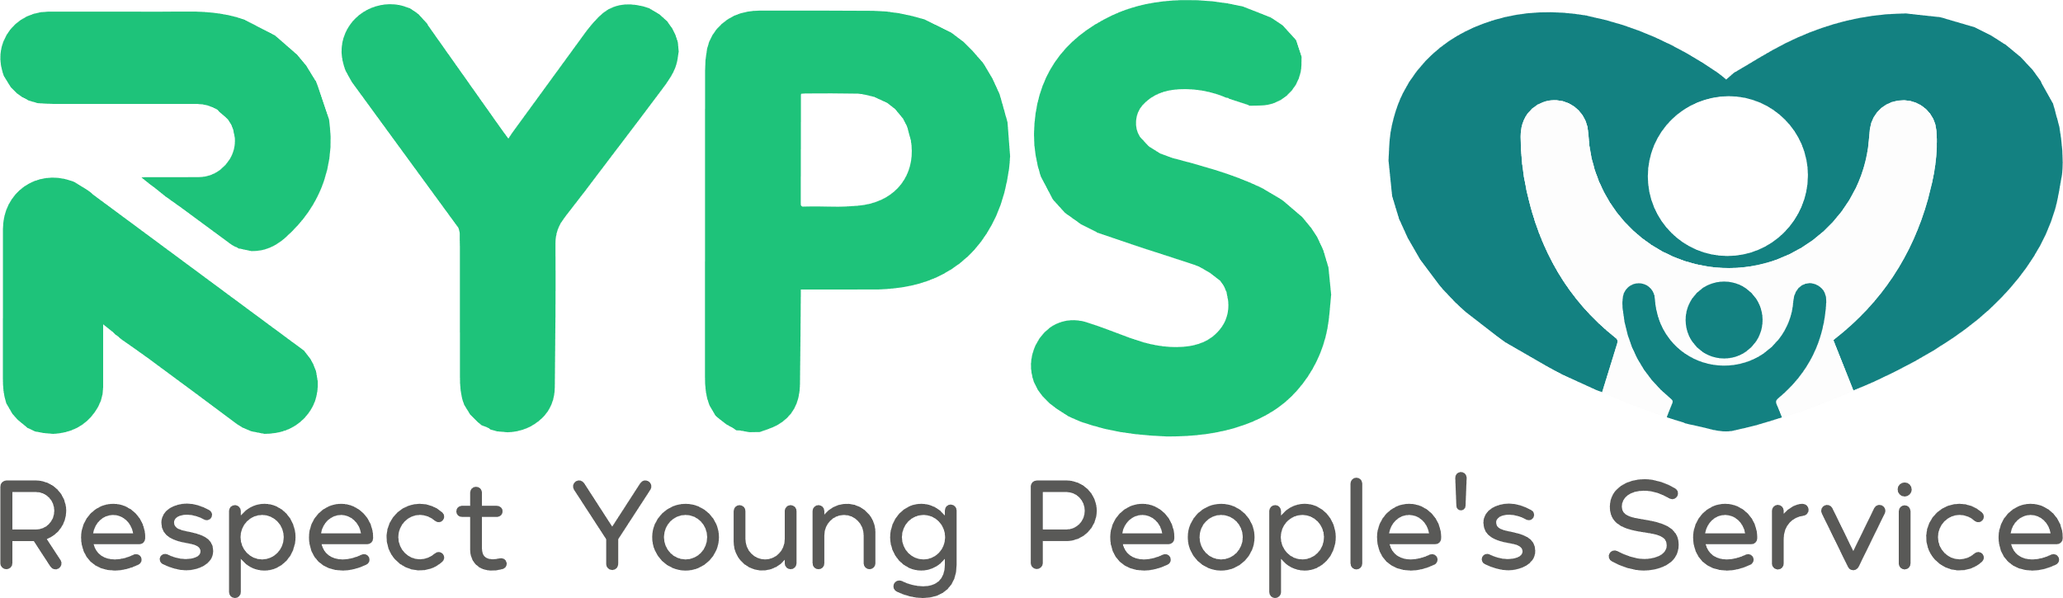 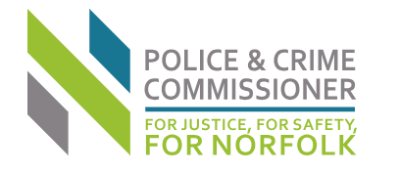

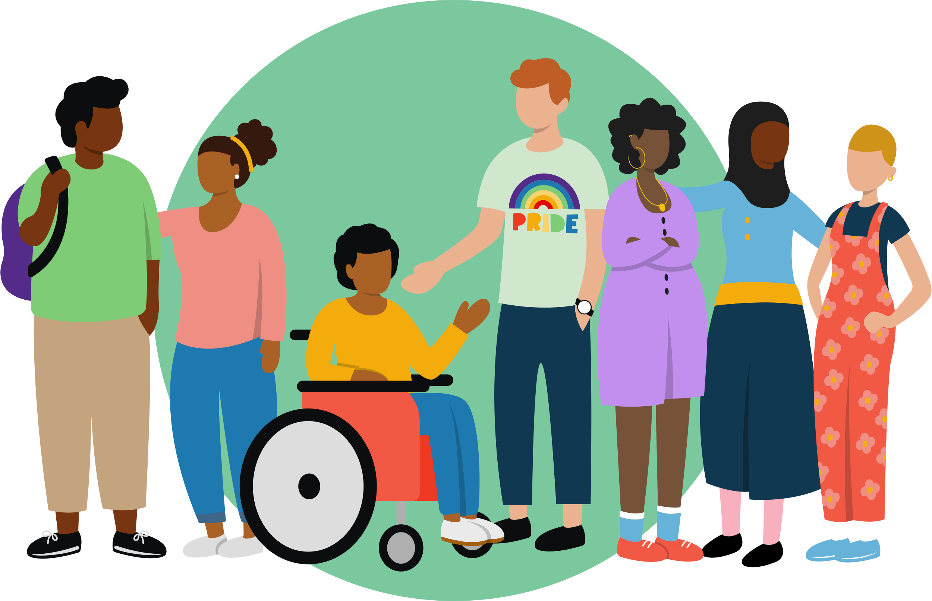

**Child and Adolescent to Parent Violence and Abuse (CAPVA)**

**Recognise and Respond**

**Course length:** 90 minutes - Delivered via Microsoft Teams

This course is aimed at multi- agency practitioners across the Norfolk area and will be delivered as briefings or in a webinar. The sessions provide an overview of Child and Adolescent to Parent Violence and Abuse, supporting participants to begin to understand the complexities of CAPVA, who it affects and why this may be happening in some of the families that practitioners are involved with.

**Session objectives include:**This session will provide a foundation to enable participants to:

* Develop an understanding of the dynamics and causal factors of Child and Adolescent to Parent Violence and Abuse (CAPVA)
* Recognise how CAPVA may present, identifying indicators and risks associated with it.
* Explore the impact of CAPVA on parents, young people who harm and other family members.
* Enable practitioners to respond to CAPVA with increased confidence.

**Dates and times of briefings:**

Wednesday 15th January 2025: 9:30-11 am

Thursday 6th February 2025: 9:30- 11 am

**Date and time of “Lunch and Learn” webinar:**

Wednesday 26th February 2025: 12- 1:30 pm

**To book your place visit:**

[NSCP Training page | Norfolk Safeguarding Children Partnership | PWWC](https://norfolklscp.org.uk/people-working-with-children/nscp-training)  
  
*These events are free to attend – Respect have been commissioned by the Office of the Police and Crime Commissioner for Norfolk enabled through the CAPVA Project.*