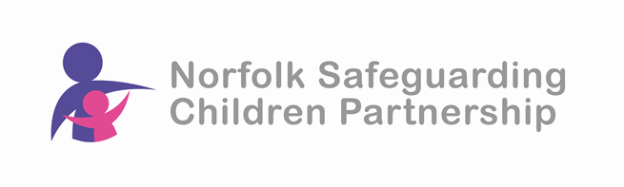

**Gangs, County Lines and Serious Youth Violence- Awareness and Preventative - St Giles SOS+**

**Delivered via Microsoft Teams**

**By attending the session, participants will:**

* have an improved understanding of gang involvement, exploitation, violence and keeping safe online.
* have an understanding of the risk factors facing young people.
* improved understanding to support informed and relevant conversations with young people about making positive choices.

**Dates and times of training:**

Tuesday 28th January 2025 – 5pm to 7pm

Tuesday 4th March 2025 – 10am to 12 noon

This is a free event but places are limited so to ensure your place please book asap.

**To book your place visit the NSCP website training page:**

<https://norfolklscp.org.uk/people-working-with-children/nscp-training>

