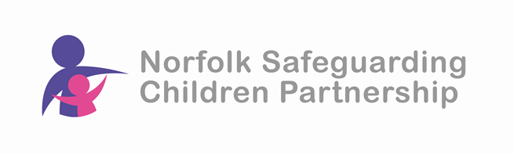
Safeguarding Children Training

Best Practice Event

6th February 2025 – 9.30am to 1.00pm

Venue: The Nest, Holt Road, Horsford Norwich

This Best Practice session is for practitioners and trainers who are developing and delivering Safeguarding Children Training in Norfolk.

Aim: To provide Norfolk’s Safeguarding Children Training network with up-to-date information regarding safeguarding children developments in Norfolk along with opportunities to further develop their training skills in this area.

Learning outcomes: By the end of the session delegates will:
- Have knowledge of understanding around Intergenerational Neglect and its impact on children
- Understand how Norfolk is addressing Accumulative Neglect
- Have received updates on key practice developments in Norfolk such as:
  - Family Help Restructure
  - Multi-Agency Chronologies
  - JAGS (Joint Agency Group Supervision)
  - Family Hubs
  - Norfolk’s Attendance Strategy
  - Father Inclusive Practice Project
- Have shared good practice and innovation in training.

This is a free event but places are limited so to ensure your place please book asap.

To book your place visit the NSCP website training page: NSCP Training | Norfolk Safeguarding Children Partnership | PWWC (norfolklscp.org.uk)

