Dear Childcare Provider

**Expression of interest for high quality childcare provision in Sprowston**

**Summary**

The CARE Federation is inviting organisations to submit applications to provide high-quality nursery provision at Sparhawk Infant and Nursery School, Sparhawk Avenue, Sprowston, Norwich, NR7 8BU

The selection process aims to deliver high-quality childcare services compliant with regulatory frameworks. The opportunity will be open for 14 working days. All applicants will be notified of the outcome on 21st May 2025, with a planned contract period from 1st September 2025.

This process presents an opportunity for businesses offering pre-school education services to expand their portfolio and support the delivery of high quality early education and childcare in Norfolk. More specifically the need is to support families to access childcare within Norwich while ensuring compliance with relevant early years and childcare standards.

The childcare provision is expected to be open all year round between 12 noon and 6pm, five days a week in term time and between 8am and 6pm in holiday periods, and offer the funded childcare entitlement for 3 and 4 year olds. However, the offer to families can be adapted to support a sustainable business model, in negotiation with The CARE Federation dependant on parental demand.

The successful setting will be expected to work closely with our school, Norfolk County Council and the wider community.

To register your interest in this opportunity and obtain further information please contact business@carefed.org.uk marked for the attention of Mrs Smith.

**Invitation**

The CARE Federation are seeking an education provider to deliver high quality, flexible and affordable 3-4 year old, early years provision in Norwich. We are looking for an education provider that is passionate about supporting the lives of children, who wants to extend their portfolio of nursery and childcare provision and enable children to reach their full potential. This could be the opportunity to make a positive difference and contribution to ensure families in Norwich have a safe, secure, and high-quality nursery to meet theirs and their children's needs.

The services must be compliant with the Early Years Foundation Stage (EYFS) Framework, and Ofsted as applicable, as well as all other relevant legislation.

It is expected that the provision will work closely with the whole community to improve outcomes for children and will provide a place of safety and support that is open to all, irrespective of gender, race, disability, sexual orientation or faith.

The CARE Federation will offer a 10-year lease to the successful applicant. However a Tenancy at Will shall be awarded to the successful organisation initially to allow operation to commence, and will remain operational until the formal lease is generated.

Please note the successful education provider will need to market and generate interest in the provision which will compliment any provision already within the locality.

The service will be based within the local authority building that has secure access, shared with the school. The school will be providing nursery care in the morning sessions (8am – 12 noon) and will therefore share the nursery space that currently includes a large nursery room, children’s toilets, a kitchenette, and an outdoor play area.

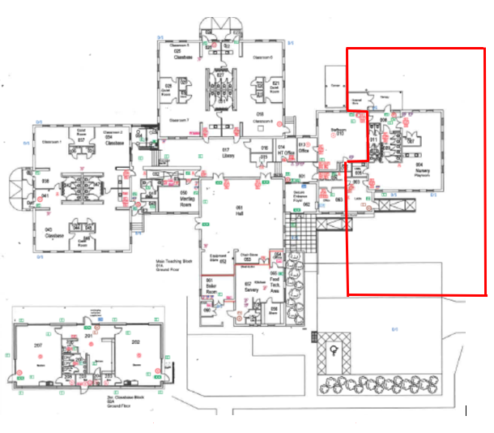

**Criteria for Selection**

The CARE Federation will use the following criteria for selection. Prospective education providers must be able to demonstrate their current experience of providing high quality childcare including:

* Appropriate details of legal status of existing organisation
* Experience of operating an Early Years setting (a minimum of 3 years is required)
* Evidence of OFSTED judgement of good or outstanding within the last 4 years
* Management experience
* Experience of running a successful business
* Effective understanding of EYFS
* Evidence of capacity to self-assess and improve provision
* Evidence of partnership working with families, other providers and services

Applications are expected to provide detail of how the applicant will run the provision, if successful, to include the following.

* Proposed management and staffing structure that meets EYFS requirements
* Proposed staffing arrangements (including qualifications which meet the EYFS requirements)
* How the applicant will ensure effective partnership working with families, other providers and services
* A proposal for marketing of the provision
* Business and financial planning including;
  + a business model canvas
  + a cashflow forecast for the first 12 months of business
  + anticipated start-up costs and how these will be funded
* Knowledge and understanding of the local community and its needs

A Creditsafe credit report may be completed to assess the financial position of the successful company/charity.

The application should detail how you would successfully develop and sustain a high-quality provision. You should include all relevant information and how you can meet the criteria listed above.

**Completed submissions must be returned by email** to : business@carefed.org.uk marked for the attention of Mrs Smith, no later than noon on the **22nd April** for EOI and **8th** **May** for full application

The candidates selected for interview will be required to give a 10-minute presentation expanding on the above criteria.

The proposed timetable for this process is as follows:

|  |  |
| --- | --- |
| Date (s) | Activity |
| **4th April 2025**  **22nd April 2025** | Notification emailed to all Norfolk providers & expression of interest emails received  Expression of interest (EOI) returned by noon |
| **24th April 2025**    **8th May 2025** | Invite to application  Applications, including business credentials to be returned by noon |
| **12th May 2025** | Providers invited to interview panel |
| **19th May 2025** | Interviews |
| **21st May 2025** | Notify applicants of the outcome of evaluation process |
| **5th June 2025** | 10 days standstill period ends, a chance for the other unsuccessful providers to complain |
| **7th July 2025** | **A tenancy at will** shall be awarded to the successful organisation and will be operational whilst the formal **lease** is generated. |
| **1st September 2025** | **Commencement of occupation** |

Please note: dates and timelines are subject to change

Should you have any questions regarding the selection process or for any further information please e-mail business@carefed.org.uk marked for the attention of Mrs Smith.

If you would like to visit the premises, please contact Mrs Smith as above to arrange a visit.