
BEFORE completing this task, it is recommended that you check and submit the Staff and Sufficiency Records.

Guidance:
- How to sign in to the Portal
- My Details (Costs)
- Staff Module
- Sufficiency Module

Part 2: Funding Agreement Data Collection – Form Submission

To complete and submit this task –

Sign in to the Provider Portal: www.norfolk.gov.uk/eyproviderportal
or
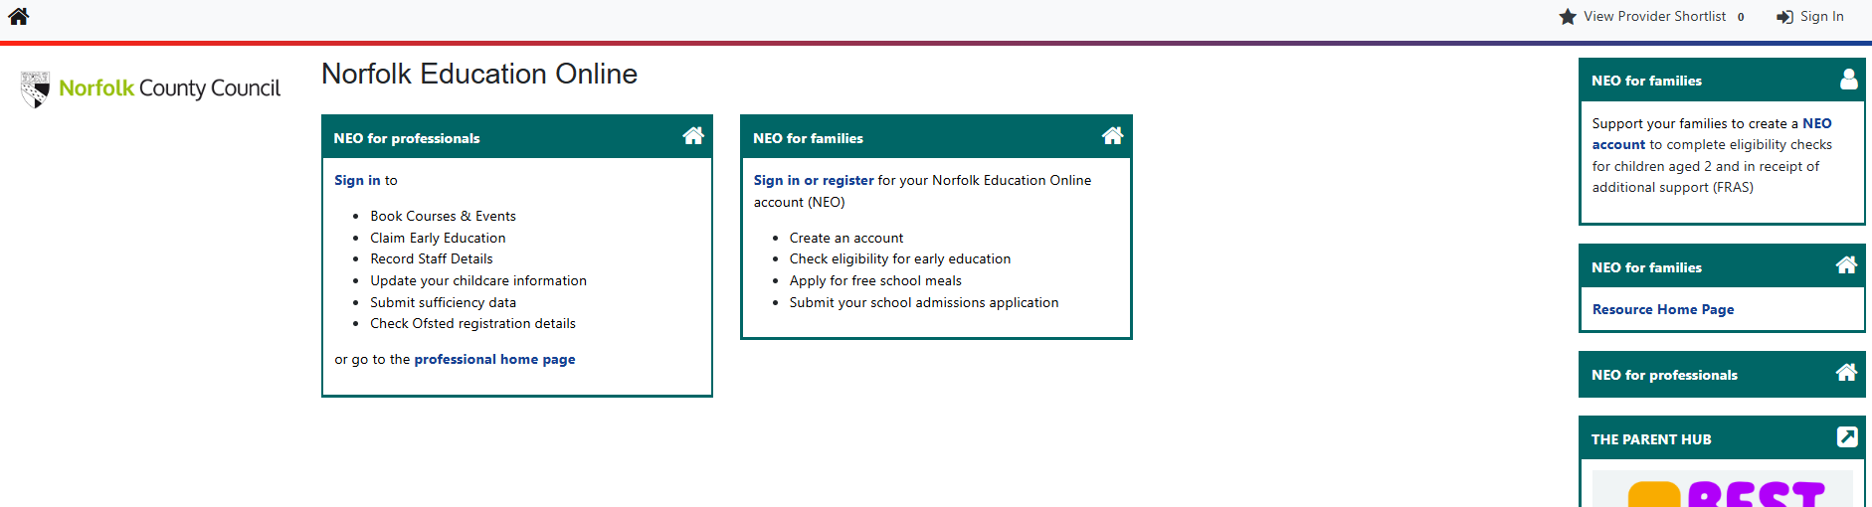

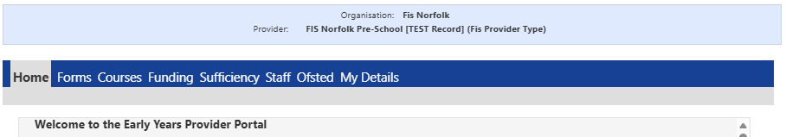

Select Forms
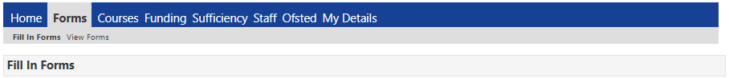

and Click on the form named EY Data Collection Form (the claim period will also be included)

[IMPORTANT] Please do not click the Submit Form Button UNTIL you have reached the last page
Introduction

- Page 1 – Details of Person Completing the form
Please enter date form is completed

- Page 2 – Registration Details All these fields are read only
Are you……….

Listed on the Early Years Register  This data has been shared with the Local Authority by Ofsted. Please check that the information is complete and correct.  If amendments are required, the Nominated Individual must contact Ofsted directly to resolve. | NOT Listed on the Early Years Register  Please check that the information is complete and correct. If amendments are required, please contact the Early Years team.

- Page 3 – Data Sharing and Consent Options
An opportunity to review and update your consent status and main contact details.
Please remember to update the date.

- Page 4 – Provider
This section is a combination of questions and a dropdown list detailing information about your setting.

- Page 5 – Childcare Offer
This section is a combination of questions and dropdown lists detailing information about your childcare fees and offer to families.

- Page 6 - Workforce
This section is a combination of questions detailing information about staff and recruitment.

- Page 7 – Sufficiency
This section is a combination of questions detailing information about childcare places, occupancy, and waiting lists.

All “open” fields should be completed with information where applicable to you/the setting. Some fields may already be populated with data currently held by the Local Authority. Please ensure this detail is checked carefully and amended where appropriate.

The form should take no more than 15 minutes to complete. All questions must be completed. If not applicable to your setting, please answer NO.

Please call or email the Early Years Team if you need any support.

01603 222300 or earlyyearsandchildcare@norfolk.gov.uk

If you need to update your Norfolk Directory Record, please complete the form named–

INFO – Norfolk Community Directory Record

Page 1: Person Completing the Form
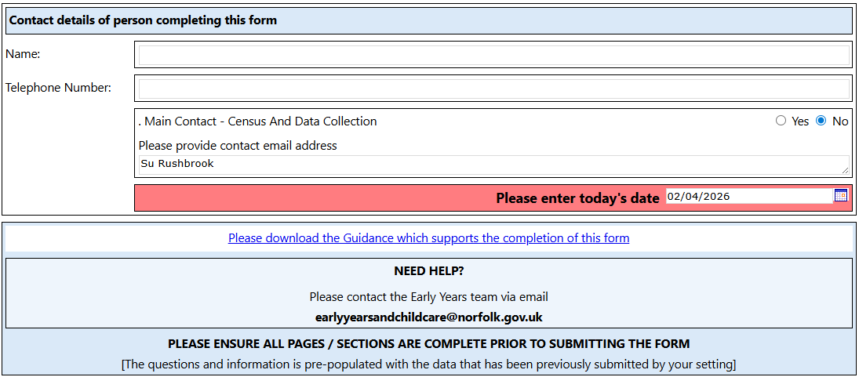 | Please enter the name and contact details of the person completing the form, together with a contact email address and date.  This person will be contacted if there is a query with the form.  PLEASE REMEMBER TO AMEND/ENTER THE DATE

Page 2: Registration
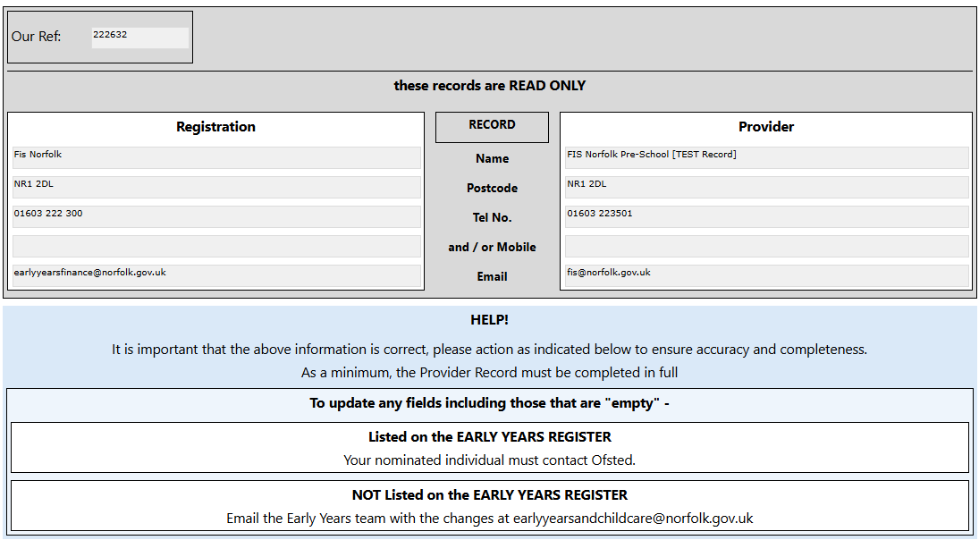 | This section is read only.  If any details are incorrect, please contact Ofsted if your provision is listed on the Early Years Register, otherwise please contact the EY team.

Page 3: Consent
If you plan to use the Norfolk Community Directory to publish your chargeable extras and early education offer, you must confirm/consent that your details can be made public here.

Childminders and providers caring for 10 or fewer children at any one time can be exempt from this requirement if preferred.

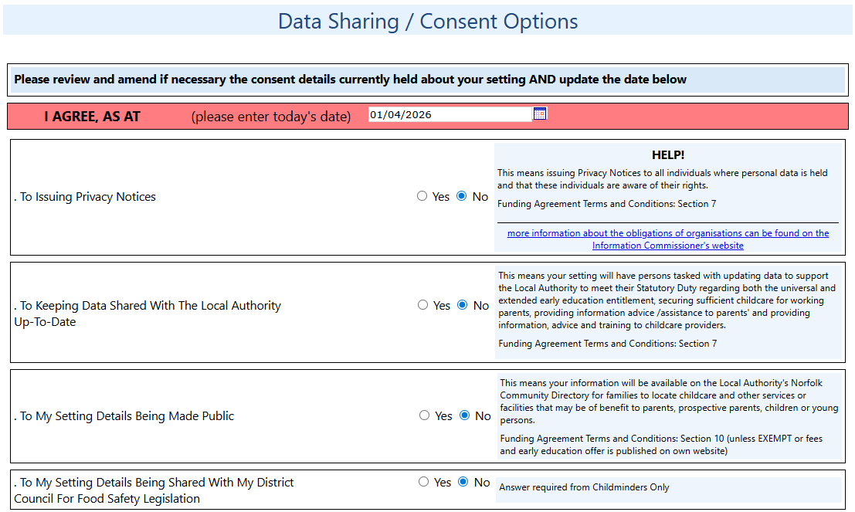  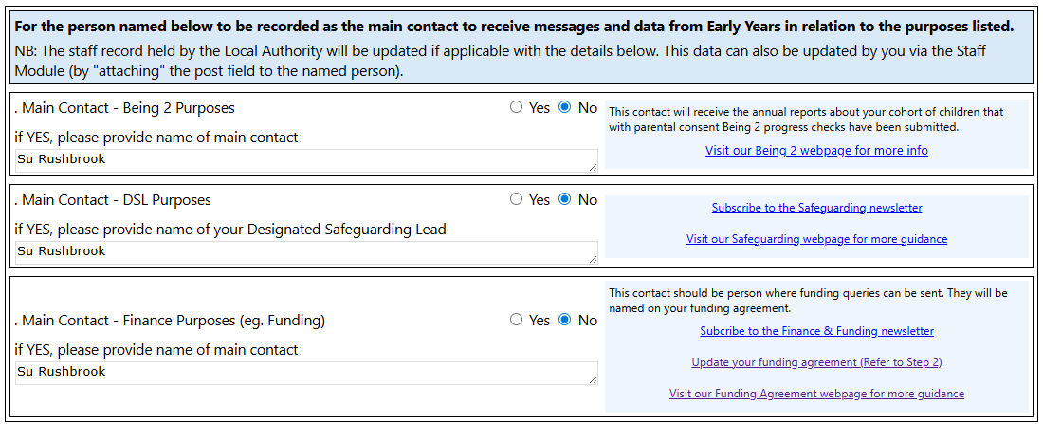 | Data Sharing and Consent Options  This section provides you with the opportunity to review and amend the consent details currently held and provide main contact details for specific roles.  Please indicate the person who is the main contact for Being 2, funding and SLP.  Childminders must also advise if they consent to their details being shared with their District Council  It is recommended that all members of your team with other responsibilities (eg. Manager, Committee, SEND and Training) should subscribe to the newsletter communications to receive current information.  BEFORE MOVING TO THE NEXT PAGE, please remember to add the date to confirm each question has been checked and consent is given

Page 4: Provider
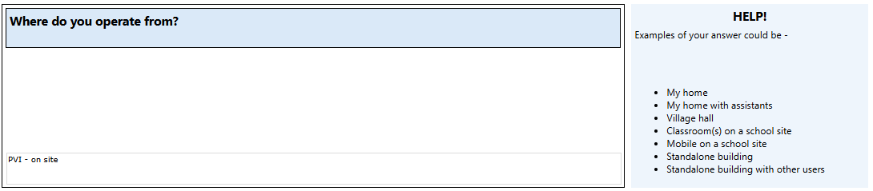 | Where do you operate from?  Please copy and paste one of the examples provided.  - My home  - My home with assistants  - Village hall  - Classroom(s) on a school site  - Mobile on a school site  - Standalone building  - Standalone building with other users
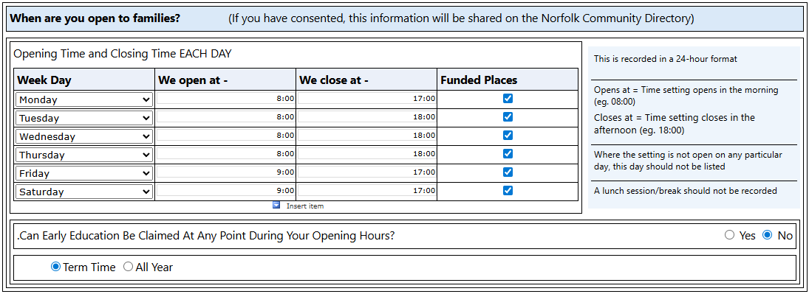 | When are you open to families?  The Daily Opening Times relate to the general opening and closing times of the provider, not the times when early education is offered.  A closure for lunch should not be recorded.  Please –  - tick “funded places” if early education is offered at any time during the times stated  - ensure the time format is 24 hours. e.g. 15:30  - do not use weekdays from the drop-down field “day”  - leave blank any day where the setting is not open
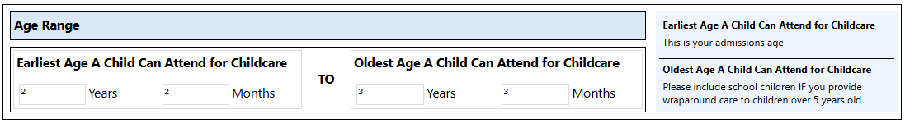 | Age Range  Please indicate the earliest age a child can attend in years and months and oldest.
  Eg. From 8 months =
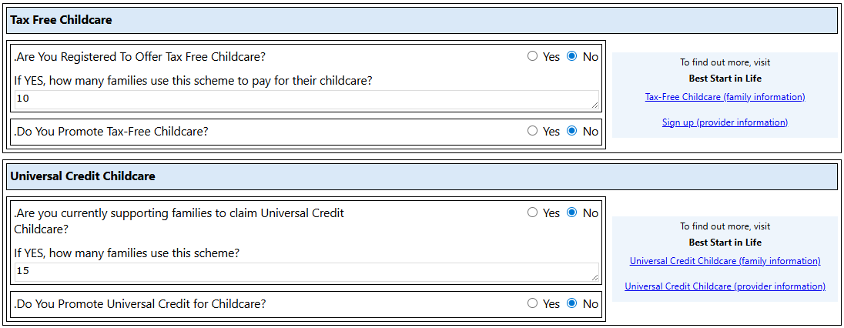 | Tax Free and Universal Credit Childcare  Please indicate if you are registered / support each scheme.  Links are provided to find out more information  - Tax Free Childcare  - Universal Credit Childcare  - Provider Info (to sign up and more)
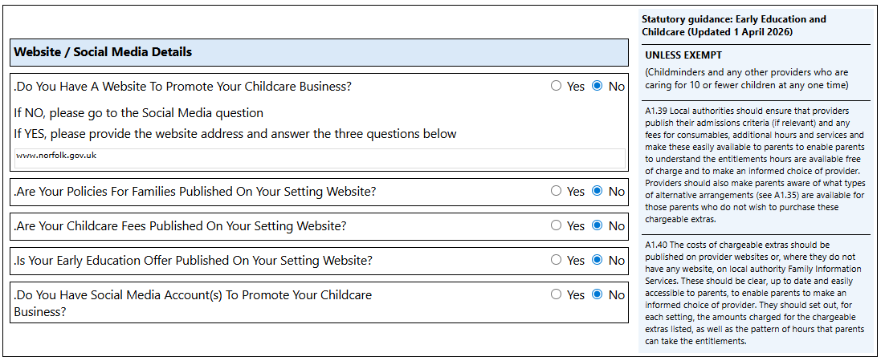 | Website / Social Media Details  Please indicate if you have a website and/or social media accounts to promote your childcare offer.  For providers that are required to publishing their information, please indicate that the following is available online –  - Policies  - Fees  - Offer (when early education is available)

Page 5: Early Education and Childcare Offer
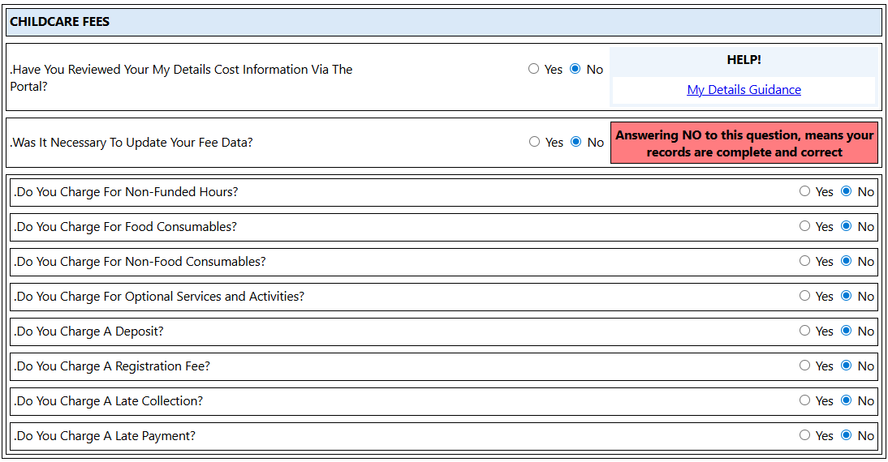 | Please indicate which fees are currently charged and that the Cost Section with the My Details tab has been checked/amended.  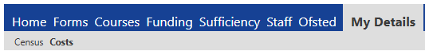  Guidance to complete this module
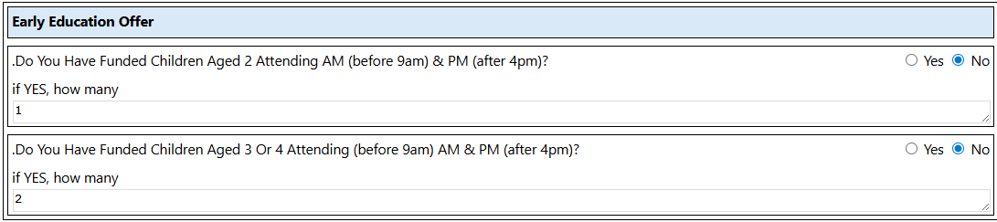 | Please indicate if funded children are attending before 9am and after 4pm in one day and if so, how many
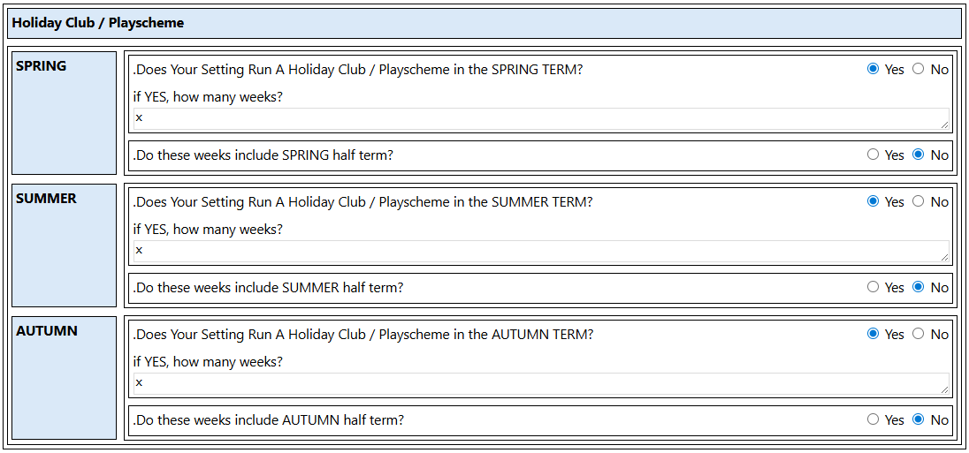 | Only required if you offer a Holiday Club / Playscheme.  Please answer NO to all questions, if this does not apply
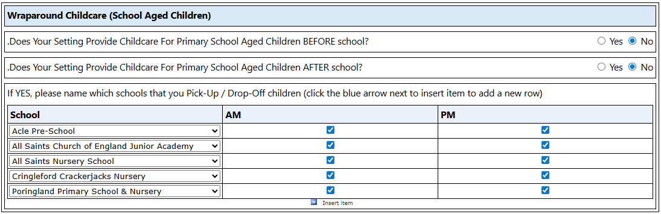 | Only required if you offer Wraparound Childcare to school aged children.  Please answer NO to all questions, if this does not apply  Click Insert Item to add any school which you drop off or pick up children from.
Only required if you offer a Parent and Toddler Group to families.

Please answer NO, if this does not apply

Page 6: Workforce
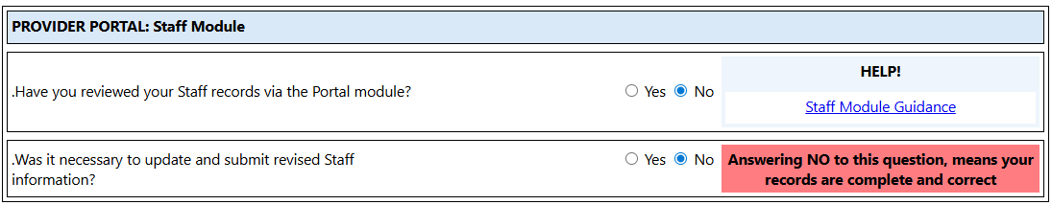 | PROVIDER PORTAL: Staff Module  The first section confirms that you have checked your staff records and amended as needed.  Guidance to complete this module
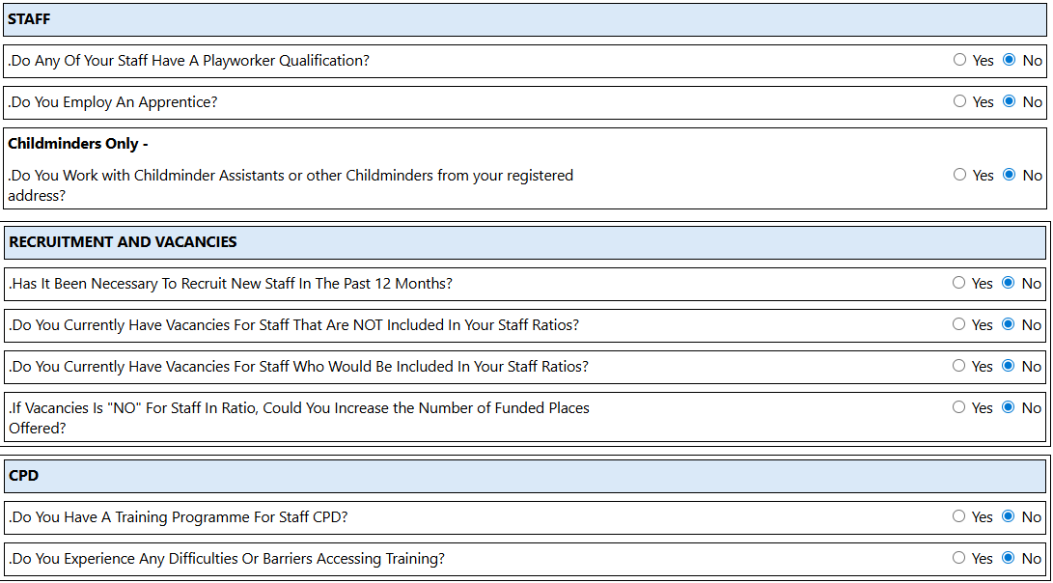 | The next sections are a combination of YES/NO questions.  We may contact you for more information.

Page 7: Sufficiency
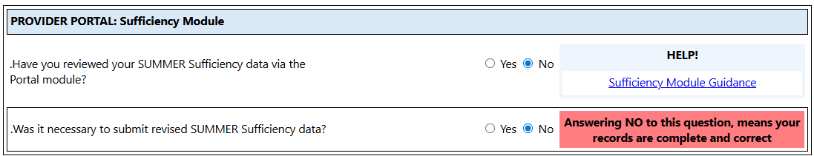 | PROVIDER PORTAL: Sufficiency Module  The first section confirms that you have checked your sufficiency data and amended as needed.  Guidance to complete this module
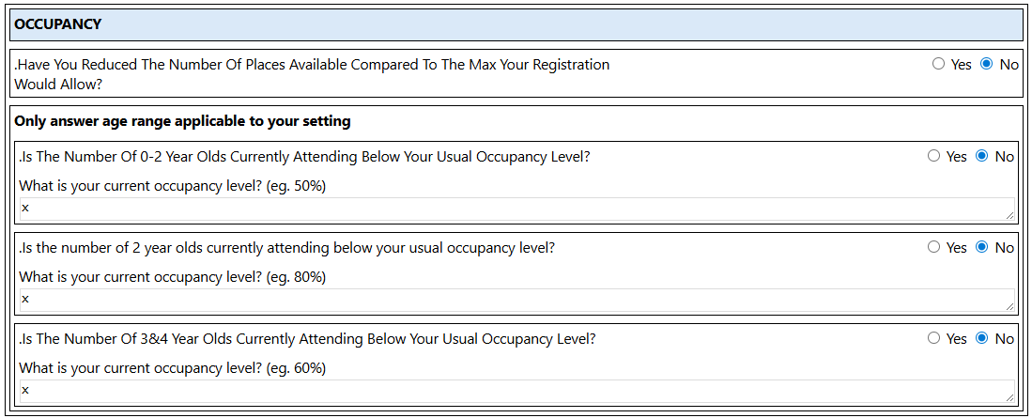 | Occupancy  This section is a combination of YES/NO questions, together with collecting your occupancy level as a %. Eg. 80%  If you are unable to accept any more children this claim period, please enter 100%.  Please do not add any narrative.
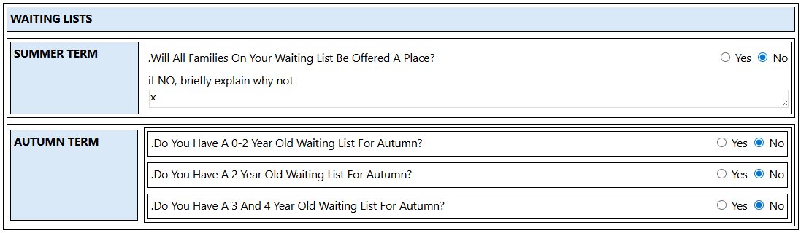 | These sections are a combination of YES/NO questions.  We may contact you for more information.

This is the final page.
Prior to submission, please use the previous page button, to check all questions have been answered and information is displayed as expected.

Submission
The form can be submitted once all checks are complete.

Click Submit Form

You may get a pop-up screen to confirm that you wish to submit the form, click ok.

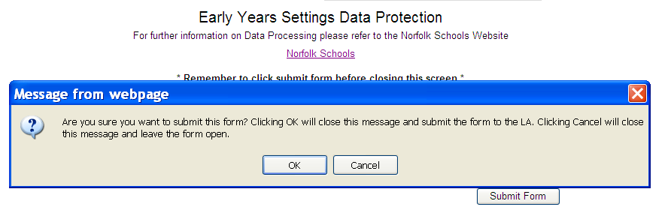

You will receive a green tick message to confirm the form has been submitted for authorisation.
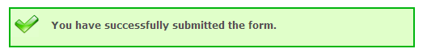

Once a form is submitted you can view its status - Click View Forms.

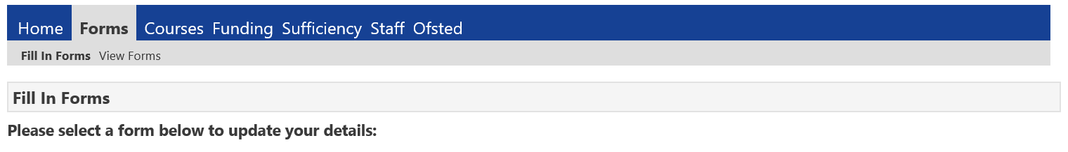

TIP!
If the form is marked PENDING, it is possible to re-open the form (click on the form marked PENDING from the list), to make any adjustments and then submit again.

