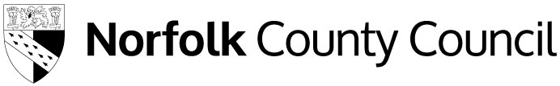
Free School Meals
County Hall
Martineau Lane
Norwich
NR1 2DH

Please ask for: Free School Meals

Direct Dial Number: 344 800 8020

Email address: fsm@norfolk.gov.uk

Date: 29 June 2026

Dear Parent / Carer,

We are writing to inform you about your child(ren)’s Free School Meals eligibility following our annual review.

Free School Meals – Annual Review

Children who were previously assessed as eligible for Free School Meals had their eligibility protected. This meant they could not lose their Free School Meals, even if the household was no longer eligible.

These protections end from summer 2026, meaning your child(ren)’s Free School Meals eligibility now needs to be reviewed each year around the summer holidays, and we let you know if anything changes.

You do not need to reapply for children who already receive Free School Meals, we will conduct the annual review without the need for a new application.

For more information, please see the guidance on our webpage www.norfolk.gov.uk/freeschoolmeals including our guide for parents, Understand Free school meals eligibility changes from September 2026.

Your Child(ren) eligibility status

Following our annual review, your child(ren) are confirmed as:

- Eligible – Expanded

Free School Meals - Eligibility explained

From September 2026, there are two types of eligibility Targeted or Expanded:

- Targeted: If your household has returned an Eligible – Targeted status this means your child(ren) are eligible for Free School Meals in addition to further support. This includes extra funding for their schools, the Holiday Activities and Food programme (HAF) and the ‘extended rights’ element of school travel assistance.

- Expanded: If your household has returned an Eligible – Expanded status this means your child(ren) are eligible for Free School Meals, but not any further support.

What happens next

We will not check your eligibility again until next year during the summer holidays.
You do not need to reapply for children who already receive Free School Meals.

If your child moves to a different school in Norfolk, their details will be updated once they start there.

More information

More information about Free School Meals, including answers to frequently asked questions are available on our webpage.

Get in touch

If you have any questions about this decision, please contact us by email at fsm@norfolk.gov.uk.

Yours sincerely

Free School Meals Team
Children’s Services

