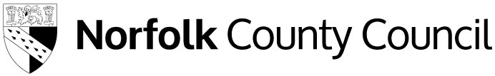
Free School Meals
County Hall
Martineau Lane
Norwich
NR1 2DH

Please ask for: Free School Meals

Telephone Number: 0344 800 8020

Email address: fsm@norfolk.gov.uk

Date: 29 June 2026

Dear Parent / Carer,

We are writing to inform you about your child(ren)’s Free School Meals eligibility following our annual review.

Free School Meals – Annual Review

Children who were previously assessed as eligible for Free School Meals had their eligibility protected. This meant they could not lose their Free School Meals, even if the household was no longer eligible.

These protections end from summer 2026, meaning your child(ren)’s Free School Meals eligibility now needs to be reviewed each year around the summer holidays, and we let you know if anything changes.

You do not need to reapply for children who already receive Free School Meals, we will conduct the annual review without the need for a new application.

For more information, please see the guidance on our webpage www.norfolk.gov.uk/freeschoolmeals including our guide for parents, Understand Free school meals eligibility changes from September 2026.

Your Child(ren) eligibility status

Following our annual review, your child(ren) are confirmed as:

- Not Eligible

We checked your details with the Department for Work and Pensions, the Home Office, and HM Revenue and Customs.

These checks show that you are not currently receiving a qualifying benefit.
Because of this, you are not eligible for Free School Meals at this time.

More information

To understand more about Free School Meals and new eligibility rules, please visit our webpage.

Get in touch

If you have any questions about this decision, please contact us by email at fsm@norfolk.gov.uk.

If your situation changes in the future and you wish to make a new Free School Meal application, please do so by visiting our webpage and clicking on “Apply for free school meals”.

Yours sincerely

Free School Meals
Children’s Services

