Schools Forum
Item no. 3

Report title: | Renewal of the NCC Group Catering Contract for Maintained Schools April 2023
Date of meeting: | 18 May 2022
Introduction
The council has a duty to ensure that there is provision for all children in maintained schools to receive a school meal. The Local Management of Schools legislation gives governing bodies the freedom to choose their own catering provider for their school. However, due to the many smaller primary schools in Norfolk, and in particular those with no cooking facilities of their own, the Council fulfils its legal obligations and ensures provision is available to all schools, irrespective of size and available facilities, by negotiating a group catering contract. The governing bodies of maintained primary schools are able to opt into this contract via a Service Level Agreement or are free to procure another solution should they wish to do so.

Executive Summary
- The Council currently has a group contract with Norse Eastern Limited to provide catering services to maintained primary schools.
- The current contract ceases on 31 March 2023, contains in the region of 119 schools, and is worth approximately £6M per annum.
- Maintained primary schools may opt into the contract by signing a Service Level Agreement with Norse but must leave if they convert to academy status. There is no obligation for maintained schools to opt into the contract, and they are free to choose an alternative supplier or provide their own meals if they wish.
- The nutritional standards, quality and value for money of the contract is monitored and reported upon by a Catering Board.
- There is no financial cost to the Council but there may be some financial risk if the contract is not renewed, as the Council may then receive a reduced dividend from Norse and there may be the potential for pension strain costs should Norse staff be made redundant as a direct result of lost business.
- The value of the contract is reducing annually as schools convert to academy status, making it less attractive to alternative suppliers.
- The operation of Norse Eastern Ltd, with reference to the Group Catering Contract has been considered by the Council’s procurement team and by solicitors from nplaw, in conjunction with a report to Norse Group from the external auditors KPMG, and it has been deemed to be Teckal compliant.
- Norse Eastern Ltd use local suppliers for the majority of the food used in the servicing of the school contract, and also meet the stringent School Food Standards, and follow the School Food Plan
- On the basis of all the considerations above, it has been agreed that the NCC Group Catering Contract with Norse Eastern Ltd should be renewed for a further 3 years, but with enhancements as agreed with the members of the Catering Board.

Schools Forum members are asked to:

- Note the contents of the report, in particular the recommendation of NCC’s Catering Board for renewal of the Norse catering contracting from 1st April 2023 for a period of 3 years;

- Discuss the proposal for renewal of the catering contract, as part of stakeholder engagement, before a final decision is made by the Executive Director of Children’s Services.

 | Background and Purpose
1.1  1.2  1.3  1.4  1.5  1.6 | There is a longstanding arrangement whereby the Council has a group catering contract with Norse Eastern Limited to provide catering services to maintained primary schools.  The council is not obliged to tender the contract, which is currently valued at circa £6M per annum, because Norse Eastern meets certain criteria about degree of council control set out in procurement law (Teckal).  Maintained primary schools may choose to sign a Service Level Agreement with Norse to be covered by the group contract. Some 119 primary schools currently opt into this arrangement, although this number is falling as schools convert to academy status.  The group contract can only cover LA maintained schools; academies are required to enter into a contract for catering, as opposed to an SLA via the Council. As schools convert to academy status during the contract term, they must therefore leave the group contract.  The group contract is monitored in terms of nutritional quality and value for money by a Catering Board comprising council officers, Norse officers and stakeholders (governor, headteacher & school finance staff representatives). The Board is content with the quality and value of the Norse contract, and that it should be renewed.  Although the contract does not end until 31 March 2023, in order to ensure that schools that do not opt to renew have sufficient time to find alternate provision and undertake any staff TUPE processes, we need to ensure that we have an indication of signup to the new contract before the end of this school term.
 | Proposal
2.1  2.2  2.3  2.4  2.5  2.6  2.7 | The proposal is that the Council continue with the Group Catering Contract with Norse Eastern Limited for a further 3-year contract term with effect from 1 April 2023, but with some enhancements to the contract as agreed with the members of the Catering Board.  The Catering Board, in negotiating with Norse Eastern Limited, discussed changes to the management fee structure to ensure the contract is financially viable and to give participating schools less financial impact on their budgets.  With costs outgrowing income in the last two years, the Group Catering Contract has become financially unviable for Norse Eastern Limited (as detailed in 4.5 of this document). If the meal price is increased to mitigate the rising costs in the next Group Catering Contract, there is a risk parents will not choose a paid school meal for their child. There is also risk that schools will have to pay more than the funding they receive from the government for UIFSM and FSM children.  Another option to mitigate the financial loss would be to charge a higher management fee, which would be in the region of £9,500 per year, again something schools would have to fund from their budgets  The proposal for the Group Catering Contract 2023-26 is to charge participating schools the eligibility of UIFSM and FSM based on the numbers/income given by the Government. This would mean the cost of the school meal service will not financially impact the school’s budget and would enable Norse Eastern Limited to maintain a reasonable meal price for parents of paid meals with the view to increase meal uptake.  In addition, discussions have led to a methodology to allow for a ‘profit-sharing rebate’ with participating members should there be excess profit at the end of each year of the Group Catering Contract.  The final contract renewal is recommended by the Catering Board, stakeholder engagement includes discussion at Norfolk Schools Forum before ultimate sign-off by the Executive Director of Children’s Services.
 | Impact of the Proposal
3.1  3.2 | The proposals will ensure there is a suitable provision available for all maintained schools, irrespective of size and available facilities, so that all children will have access to a school meal and thereby ensure the council’s duty is fulfilled.  Should the Council not negotiate a group contract, there would be the risk that a number of small rural schools, particularly those without kitchens, would not be able to find a suitable alternative supplier and children would therefore not be able to benefit from a school lunch. The Council would then be failing in its duty to these children.
4.1  4.2  4.3  4.4  4.5 | Evidence and Reasons for Decision  A full stakeholder consultation regarding the school meal provision in Norfolk was undertaken in 2008 and 2009, using external consultants Impower Limited. The recommendations included a detailed change programme, which led to the formation of a Catering Board to oversee the introduction of the group catering contract with Norse Eastern Limited and to report on the nutritional standards, quality, and value for money of the contract.  The Board meets termly and considers performance against a series of agreed key performance indicators: service-wide; financial; team development; customer service.  The Chair of the Board (an LA Officer) also receives and responds to any customer complaints that cannot be satisfactorily dealt with by Norse.  The contract was initially for a 3-year period from 1 April 2011 and was subsequently renewed for further 3-year periods from 1 April 2014 to 1 April 2017, 1 April 2017 to 1 April 2020, 1 April 2020 to 1 April 2023. This current contract is due to end on 31 March 2023.  The current Group Catering Contract has become financially unviable as costs have outgrown income in the last two years.  To summarise:  - Year 1 April 2020/21  - Income - UIFSM increase of 1.74%. No further meal price increases.  - Year 2 April 2021/22  - Income – FSM increase of 0.65%. No further meal price increases.  - Costs – Labour increased by 2.18%. Food cost increased by 2.9%  - Year 3 April 2022/23  - Income – FSM increase of 1.53%. No further meal price increases.  - Costs – Labour increase of 6.6%. Food cost increase of 6.25%
 | Alternative Options
As the number of schools in the contract have reduced over the 3-year contract periods due to schools converting to academy status, it has also reduced the attractiveness of the contract to alternative suppliers.

NCC are currently working with Norse Eastern Ltd to consider options for facilitating academy schools to remain in at the point of conversion or re-join the group contract whilst still enabling it to remain Teckal compliant. Schools and academies will retain the freedom of choice but academy schools will have the group contract as a further option that they currently do not have access to.

 | Financial Implications
6.1  6.2  6.3  6.4 | There is no explicit cost to the Council, as all costs of school meals fall to school budgets (for the management fee and for free / adult duty meals) or to parents (for pupil paid meals) or to school staff (for adult paid meals). The Council is not taking the risk relating to volume; if schools leave the contract, the council passes the reduction in income directly through to Norse.  There is a potential cost to the Council if the contract is not renewed with Norse Eastern Limited, as a dividend of the profits of this company is returned to the County Council each year.  There is a separate agreement with Norse concerning pension liabilities. As a result of this, the Council is taking a risk regarding pension costs on redundancy if Norse loses business (although we would generally expect staff to transfer to the new provider under the Transfer of Undertakings (Protection of Employment) (TUPE) regulations.  Additionally, there is currently a cost to the Council for the administration and management of the group contract, which is undertaken by Education Finance on behalf of Children’s Services Department. Norse currently pays a management fee to defray the costs incurred in managing the contract and collecting the income.
 | Resource Implications
 | Staff: N/A
 | Property: N/A
 | IT: N/A
 | Other Implications
 | Legal Implications Nplaw and the Council’s procurement team have been involved in the contract renewal throughout. Senior Counsel’s opinion has affirmed the correctness of our procurement approach and also continued use of our current contract structure.
Human Rights implications
No implications
 | Equality Impact Assessment (EqIA) (this must be included)
The Catering Board completes the EqIA as part of the contract renewal by considering items including but not restricted to the following:
- The availability of a nutritionally balanced school meal for all children, including those who are eligible for Free School Meals
- The availability of a nutritionally balanced school meal for those children with restricted diets for any reason (e.g. medical, religious, ethical etc.)
The employment terms & conditions for staff employed in school kitchens
Health and Safety implications (where appropriate)
There are no specific implications; however, the Catering Board receive reports from Norse Eastern Limited at every meeting in relation to Health & Safety matters such as incidents and staff training.
 | Sustainability implications (where appropriate)
There are no specific implications; however, the Catering Board consider the sustainability of the contract including impact upon the environment. Norse Eastern Limited use in the main, local suppliers to service the contract, with the majority of food being sourced from local farmers and growers.
The Catering Board also discuss such topics as the impact upon the contract of such issues as the Healthy Schools agenda and Covid.
 | Risk Implications/Assessment
 | There are no other issues or risks other than those listed elsewhere in this document.
 | Recommendations
 | To note the contents of the report and the renewal of the Group Catering Contract with Norse Eastern Ltd with effect from 1 April 2023 for a period of 3 years.
 | Background Papers
 | None

Schools Forum members are asked to:
- Note the contents of the report, in particular the recommendation of NCC’s Catering Board for renewal of the Norse catering contracting from 1st April 2023 for a period of 3 years;

- Discuss the proposal for renewal of the catering contract, as part of stakeholder engagement, before a final decision is made by the Executive Director of Children’s Services.

Officer Contact
If you have any questions about matters contained in this paper, please get in touch with:

Officer name: | Alison Randall | Tel No.: | 01603 224273
Email address: | alison.randall@norfolk.gov.uk

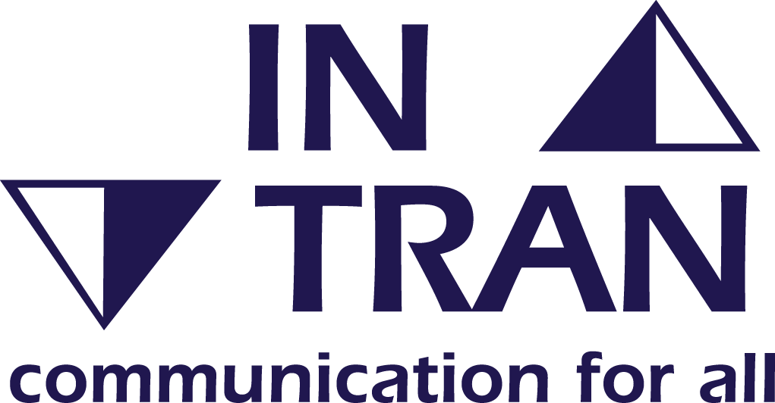 | If you need this report in large print, audio, braille, alternative format or in a different language please contact 0344 800 8020 or 0344 800 8011 (textphone) and we will do our best to help.

