NORFOLK SCHOOLS FORUM

AGENDA

Meeting on Friday 8 July 2022 09:00 – 12:00 noon

Venue: South Green Park, Mattishall

Members will be asked on the day for their permission to record the meeting.

Individual members, named below, are asked to provide verbal reports for these items.
09:00 | 1 | Welcome and Introductions  Apologies | Report
09:05 – 09:20 | 2 | Minutes of Last Meeting and Matters Arising  - Central Schools Services Block – members requested a report from the Authority on the way in which teams are put together in relation to their responsibilities to schools. (This item was deferred to the July meeting in order to allow time to consider the impact of the Government Schools White Paper to enable consideration by Forum of future expectations of LAs).  - Finance briefings for schools – verbal feedback  - School Catering Contract - update to Forum  - Outcome of National SEND Review/Green Paper – collective response from Schools Forum |  | 3 - 9
09:20 – 09:45 | 3 | MyOracle Update | Verbal
09:45 – 11:00 | 4 | Dedicated Schools Grant (DSG)  - Norfolk’s Dedicated Schools Grant Recovery (Phase 2) within DfE Safety Valve Programme (paper from Michael Bateman)  (Break)  - DSG Management Plan update (paper from Martin Brock) | Information/  Comment  Information/  Comment | 10 - 17  18 - 25
11:00 – 11:30 | 5 | Consultation on Scheme Changes (papers from Martin Oswick/Martin Brock)  - Analysis of Balances  - Salix/Building Maintenance Fund Limits | Decision  Decision | 26 - 34  35 - 39
11:30 – 11:40 | 6 | Appointment of Vice Chair for future meetings
11:40 – 11:50 | 7 | Review Future Meeting Plan |  | 40 - 41
11:50 – 12:00 | 8 | Any Other Business
 | 9 | Date of Next Meeting  Friday 30 September 2022 09:00 – 12:00 hours  Venue TBC

Norfolk Schools Forum

Minutes of Meeting held on Wednesday 18 May 2022
09:00 – 12.00 hours
Teams Meeting

Present: Representing
Adrian Ball, Diocese of Ely Multi Academy Academies
Trust
Lacey Douglass Early Years Representative
Mike Grimble, Avenue Junior School Primary Maintained Governors
Bob Groome National Education Union

Peter Pazitka, SJB CMAT Academies
Sarah Porter, The Heart Education Trust Academies
David Shaw, Creative Education Trust Academies
Sarah Shirras, St Williams Primary Primary Maintained Schools
Joanna Tuttle, Aylsham High School Secondary Maintained Schools
Martin White, (Chair) Nebula Federation Primary Maintained Governors
Vicky Warnes National Education Union
Michael Bateman Assistant Director, SEND Strategic Improvement & Early Effectiveness
Martin Brock Accountant, Schools, SEN, and Early Years
Marilyn Edgeley Admin Officer
Dawn Filtness Finance Business Partner
Nicki Rider Head of High Needs SEND
Chris Snudden Director of Learning & Inclusion
Alison Randall Head of Education Finance
Andrew Lipscomb Norse

Apologies:
Chris Caddamy, (Vice Chair) City College 16 – 19 Representative
John Crowley Assistant Director Learning & Achievement
Sally Cutting Senior Accountant
Keith Bates, Eaton Hall Specialist Academy Special School Academy
Glyn Hambling, Unity Education Trust Alternative Provision
David Hicks Academies
Howard Nelson, Diocese of Norwich Diocesan Board of Education
Carol Jacques Maintained Nursery School
Clare Jones, Boudica Schools Trust Academies
Rebecca Wicks, The Clare School Maintained Special Schools

Sara Tough Executive Director Childrens Services

- Welcome and Apologies

The Chair welcomed members to the first face to face meeting since before lockdowns began.

Apologies received as above.

It was noted that Chris Snudden would join the meeting via a zoom call.

- Minutes of the Last Meeting and Matters Arising

Accuracy of minutes for 19.1.22 Schools Forum meeting - Page 7 – the word ‘nothing’ should be changed to ‘noting’.

It was agreed the minutes were otherwise a true record of the meeting.

- Alternative Top-Up Funding Maintained Special Schools – timeline and proposal on how to keep the process under on-going review. Part of agenda item 4c.
- Independent Places Price Increases - Forum to work with other regional Forums to compose a letter lobbying the DfE on price increases. Part of agenda item 4c.
- Finance briefings for schools – Dawn Filtness/Sarah Shirras/Martin White to discuss after this meeting.

- Central Schools Services Block – members requested a report from the Authority on the way in which teams are put together in relation to their responsibilities to schools. This item is deferred to the July meeting in order to allow time to consider the impact of the Government Schools White Paper to enable consideration by Forum of future expectations of LAs

Pupil variations have been emailed to members prior to this meeting.

- School Catering Contract - Alison Randall/Andrew Lipscomb

The LA currently has a contract for Norse Eastern Limited to provide catering services to primary maintained schools. A paper with proposals for the 2023-26 contract was presented.

The paper is for information/discussion as part of stakeholder engagement and the final decision sits with the Executive Director of Children’s Services.

The proposal for the Group Catering Contract 2023-26 is to charge participating schools the eligibility of UIFSM and FSM based on the numbers/income given by the Government. This would mean the cost of the school meal service will not financially impact the school’s budget and would enable Norse Eastern Limited to maintain a reasonable meal price for parents of paid meals with the view to increase meal uptake.
In addition, discussions have led to a methodology to allow for a ‘profit-sharing rebate’ with participating members should there be excess profit at the end of each year of the Group Catering Contract.
Comments:
- Norse is proposing that all the Universal Free Schools Meals budget would go to Norse in full and Norse would provide meals going forward.
- Officers said that Norse is making a pledge to have an impact on healthy eating.
- The LA has an obligation to have a contract – the changes to this contract are designed to be fairer and more cost effective.
- Comment made that this is the right proposal and asked how much is dependable on schools not academising .
Officers said that some schools come back into the contract after academising.
- Officers said there will be no impact on schools – we are trying to future proof the contract.
- Comment that this would be better for small schools.
Norse said that only 20% of schools would be liable and these are the larger schools. Fairer for everybody.
- Comment that this proposal would be using money for its intended purpose – will have an impact for schools on things like dining room set up etc.
- Question – why did the contact not go out to competitive tender?
Officers have sought advice for the legal department and were told there is no requirement to go out to tender.

Members said that going out to tender was a question of transparency. Members commented that Norse has been providing quality meals. Members felt uncomfortable with this proposal going ahead without a tender process.

Conclusion
Officers agreed to do more work on the proposal to allow time to mitigate Forum members concerns. Officers will act on this quickly and send out an update to Forum as soon as possible.
Norse said they appreciate concerns around not going out to tender- they reiterated that they provide balanced meals and are local company.

- Dedicated Schools Grant 2021/22 Outturn

The overall DSG outturn position for all four blocks was £22.179m overspend – most of the overspend was attributed to the High Needs Block. A paper was presented by Martin Brock setting out the year end position for all DSG blocks and the cumulative DSG overspend.

The paper is for information only, comments are welcome and will be recorded.

School Block Section – At the end of the 2021-22 financial year, there was an underspend of -£0.322m.
There were no comments.

Central Schools Services Block – The Central Schools Services Block underspent by -£0.010m
There were no comments.

High Needs Block - The High Needs block overspend at year end was £21.681m.
The DSG Management Plan was discussed earlier in the year and it had been indicated that there would be significant variances on the High Needs Block.

The High Needs Block overspend had reduced by £1.030m compared to the January’22 DSG Management Plan forecast, down from an estimate of £22.711m.

Comments:
MG – Independent Places -is there any improvement in services or just an inflation in costs.?
NR – Difficult to pin down to a global view because that represents a significant number of different schools within Norfolk and outside. However the Independent sector is responding better to expectations but whether that represents value for money when maintained schools achieve fantastic outcomes at a fraction of the cost.
MG – concern is for the quality for pupils if this is going down but the cost are rising.
DF - Nationally the cost of independent places is significantly higher than maintained provision and is linked to supply and demand. We have in meetings with Department for Education raised the subject of regulation in prices for the independent market. This would have a significant impact if we paid the same to independent schools as we pay our special schools/academies we would wipe out most of our in-year deficit.

It was noted that placements in year have increased to 70. This is because, following tribunals, children are going into special schools earlier in the year. Schools are increasingly saying that these children’s needs cannot be met in mainstream, in the past we had been able to manage these pupils in mainstream until September. This has added notably to our problems and costs.

MW – there are children in primary schools in inappropriate provision because no special places are available and they would welcome a child going into a special school earlier.
Although this is not an authority recourse the system is broken!

Independent placements, a reduction of -£0.551m, previously over-estimated, mainly due to former TPG/TPECG grant monies budgeted for potential fee increase claims that are not required to be automatically distributed to providers (the LA requires evidence of pay/pension cost pressures as part of fee increase requests);. We will look in future at whether we can reduce the forecast on this line.

JT - Are you saying that if independent schools come to you and say they have cost pressures on their staff they can come to the Local Authority – why is there a mechanism for this. Is it ethically right that we would pay this out?
Officers said that when the DfE rolled the Teachers Pay and Pension Grants into the DSG they allowed an amount of that which can be used to meet increased costs in independent schools. The LA requires evidence of the increased costs, to consider before making a payment, providers are not paid automatically for this, hence the saving.

MG – Are we still looking at £150m running deficit?

Officers said they are not suspecting any significant change on the next DSG Management Plan update in July. We are forecasting an £18m deficit in 2022/23.

There were no further comments on the High Needs Block.

Early Years Block - The Early Years Block overspent by £0.829m which will be transferred to the Dedicated Schools Grant reserve as part of the in-year DSG deficit.
We did report previously that we had over-allocated the rate to providers by £0.06p in 2021-22 due to the maximising the hourly rate distributed and minimising the level of contingency.
Increased demand for SEN allocation had also added to the overspend.

There were no comments on the Early Years Block.

School balances – The total School Balances is £17.684m.

It was confirmed that no schools converted with a deficit balance.

It was confirmed all balances have been reconciled and no money has been re-distributed.

Officers said that a paper around school balances will be brought to the July meeting with a view to consult in the Autumn.

- Outcome of National SEND Review/Green Paper – presentation by Michael Bateman

Presentation slides will be distributed to Forum members after this meeting.
The consultation on the Green paper has been extended to the 22 July and we would urge individuals to respond as well as groups.
The PowerPoint will help to give members a summary and the key points in the Green paper – however we do suggest that members read the Alternative Provision section of the Green Paper. The questions in the consultation do suggest the government has more work to do on this so we need to mindful in our responses.
BG – If we want to put out to our members is there any special groups we should target?
Officers suggested all members or a collective response and send out the government link to the Green Paper consultation.
Officers suggested an individual school response as well as a School Forum response.
MG – Does the paper suggest a figure that would fix the system.
Officers – No
PP – when standard tariffs are introduced across the sector including independent providers what do you think will happen to the independent sector?
Officers – We have some independent schools who are just trying to do the right thing – could we do something if they were to lose out?
There is quite a bit of work by the DfE already done on this with the independent sector. However this got kicked in to touch as it was too difficult. This is an area fraught with risk in terms of application of the green paper. There would be an enormous push back from the independent sector and it will be how much of an appetite the government has to get to grips with this.
JT – Make sure tariffs substantial for mainstream schools to incentify schools to be inclusive – this needs to be a strong message.
The consultation paper suggests questions to consider when responding to the consultation.
Action - It was agreed that the Chair would produce a collective response from Schools Forum and that members would email their views to the Clerk of Forum by 30 June.
Emails to marilyn.edgeley@norfolk.gov.uk

Safety Valve
A national approach that could assist with balancing high needs budget. The Safety Valve is the government response to increasing number of local authorities with deficits. The link to the Green paper and the Safety Valve is significant. Local authorities with largest deficits have been invited to the Safety Valve Programme one of these being Norfolk.
Officers said it was worth noting that they had carried out work on thresholds 4 years ago, expectations of demand management, but the DfE asked this to be taken down. The paper suggests questions to consider when responding to the question of the Safety Valve.

Management Plan
The Safety Valve is saying come up with a plan and how long the plan will take to achieve a balanced budget and then talk about the accumulative.
Officers said whilst clearly this is about having a financial recovery plan it is clear the emphasis is on how the whole system responds. As we go forward very much about how we work with all strands. What a refreshed set of expectations might be on the whole system. Will need to be a plan that the whole county signs up to.

Officers said that although work had carried on through the pandemic there were items of matters arising from previous discussions around alternative funding, place price increases and element 3 funding. Offers feel that with the work around the Safety Valve they would need to press the pause button on these items until they find out what the outcomes are of the Safety Valve programme.

An updated Management Plan which will include comments from our conversations with the DfE will be discussed at the Forum July meeting.
Officers said that a letter from the DfE implies that School Forum may not have a say in future block transfers. However this should not send alarm bells ringing, it could well be that in the future this is built into contributions from the DfE.

Officers are having an introductory meeting with DfE then subsequent meetings and the Chair of School Forum along with other members will be involved.

It had been intended to plan Headteacher finance briefings for this term.
Action: Dawn Filtness/Sarah Shirras/Martin White to meet after this meeting.

- Future Meeting Plan
Members were in favour of a face to face meeting for July Schools Forum.

- Date of next meeting
8 July 2022 09:00 – 12:00 – South Green Park, Mattishall

Schools Forum
Item No. 4a

Report title: | Norfolk’s Dedicated Schools Grant Recovery (Phase 2) within DfE Safety Valve Programme
Date of meeting: | 8 July 2022

Executive summary
This report provides an update to on Norfolk’s involvement in the Department for Education’s Safety Valve Programme and the linked development of phase 2 of the Dedicated Schools Grant Recovery.

In this update:

- Summary of the Safety Valve programme and links to the SEND Green Paper;
- Actions and activity during the Summer and Autumn, including a timeline of the Safety Valve programme for Norfolk;
- Next steps.

For information only. Comments from Forum are welcome, will be recorded and considered by the Local Authority.

Context
At the Schools Forum meeting in May we provided a presentation on the governments SEND Green Paper and the associated Safety Valve Programme.
The SEND Green Paper is currently within a consultation period running from end of March to 22 July.
The Safety Valve Programme is the DfE initiative working with LAs with the highest DSG/HNB overspends (cumulative) and Norfolk has recently been invited into the programme.
Due to the tight timeline of the Safety Valve Programme, the July Schools Forum meeting may be the only opportunity to share Norfolk specific information regarding the programme with the whole Forum ahead of the DfE deadline of 15 September for submitting a draft revised DSG Management Plan.
The is a FOR INFORMATION report and we will update Schools Forum in the autumn term as our involvement in the programme continues, including the plan submitted and an update on responses from the DfE and / or the Secretary of State.
The SEND & AP Transformation Programme, Area SEND Strategy and our Written Statement of Action response to the Local Area SEND Inspection combine to form a complex SEND strategic improvement programme in Norfolk, operating now for over 3 years. The 2nd phase of this programme will begin in the autumn and aligns with the themes of both the safety valve programme and SEND green paper; we are well positioned to maximise the benefits of this new direct work with the DfE to address Norfolk’s remaining SEND challenges.

Summary of Safety Valve Programme and links to the SEND Green Paper
The DfE published information relating to the safety valve programme. The extracts below illustrate the purpose behind the programme and the 5 key themes from the learning from the LA’s who have already been engaged in the programme:
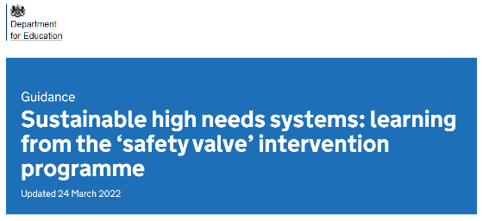
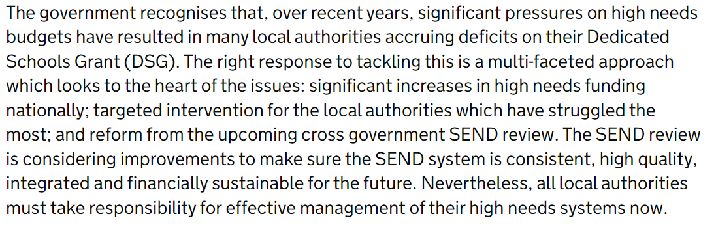
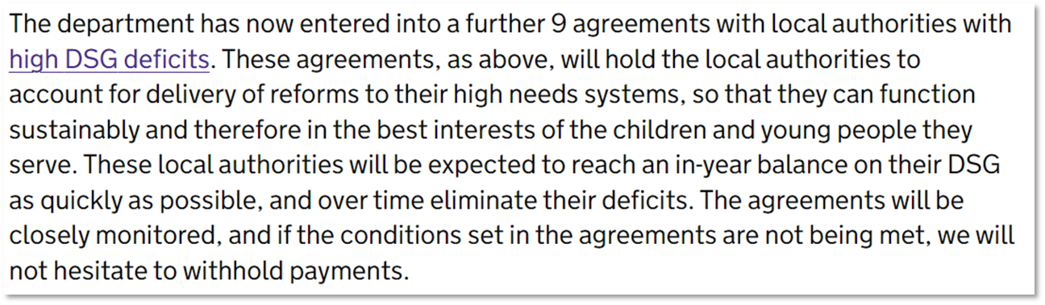
Since the DfE published their safety valve information (March 2022) additional LAs’ plans have been added to the website. The full list of LAs formally in the programme is now:
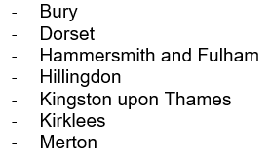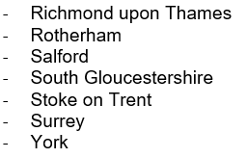
Across the 14 published plans, the DfE have determined five themes that illustrate the approach being taken within these individual safety valve programmes, these are:
- Early Intervention Focus
- Increased SEN Support Offer
- Review EHCP Assessment Process and Thresholds
- Culture change and work with school leaders
- Appropriate and thorough provision mapping, with potential development of more local provision

The ‘detail’ of these elements have been set out by the DfE in this way:
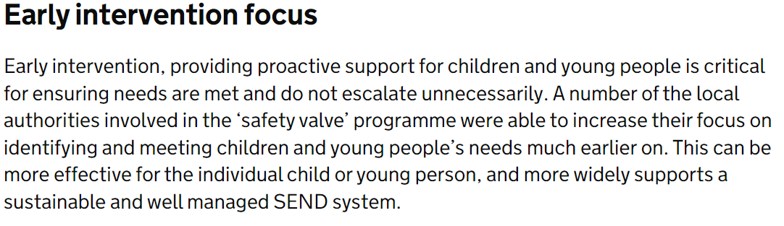
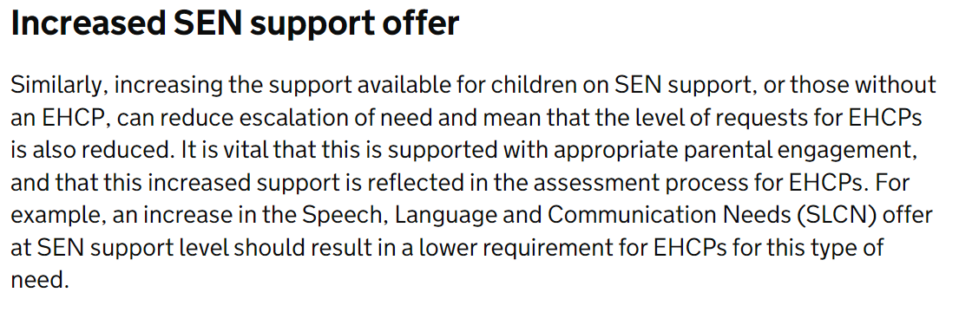
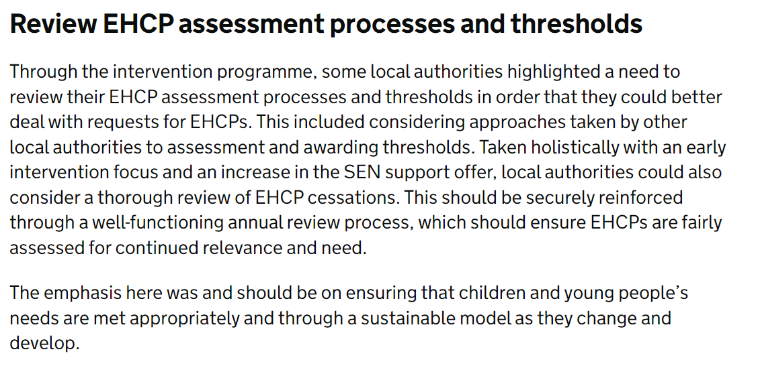
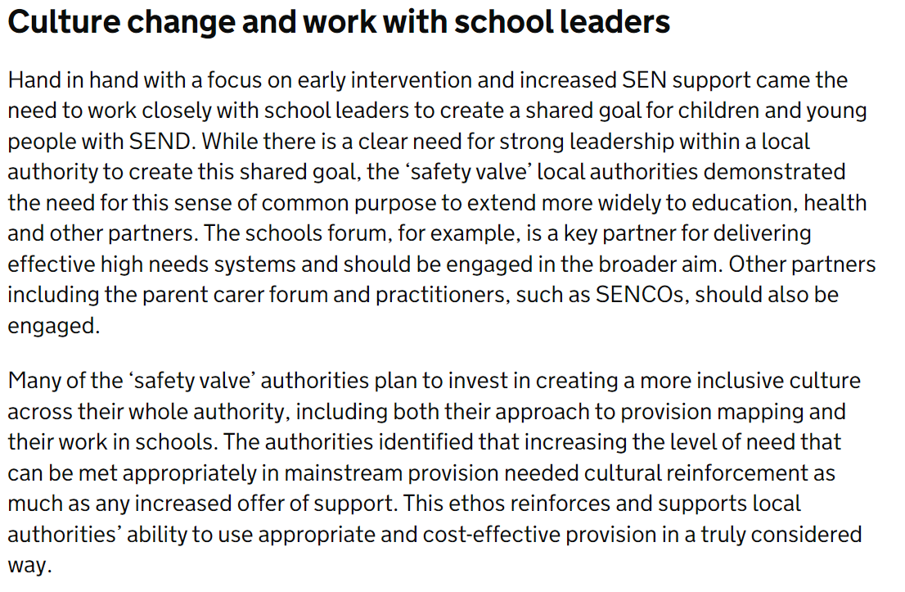
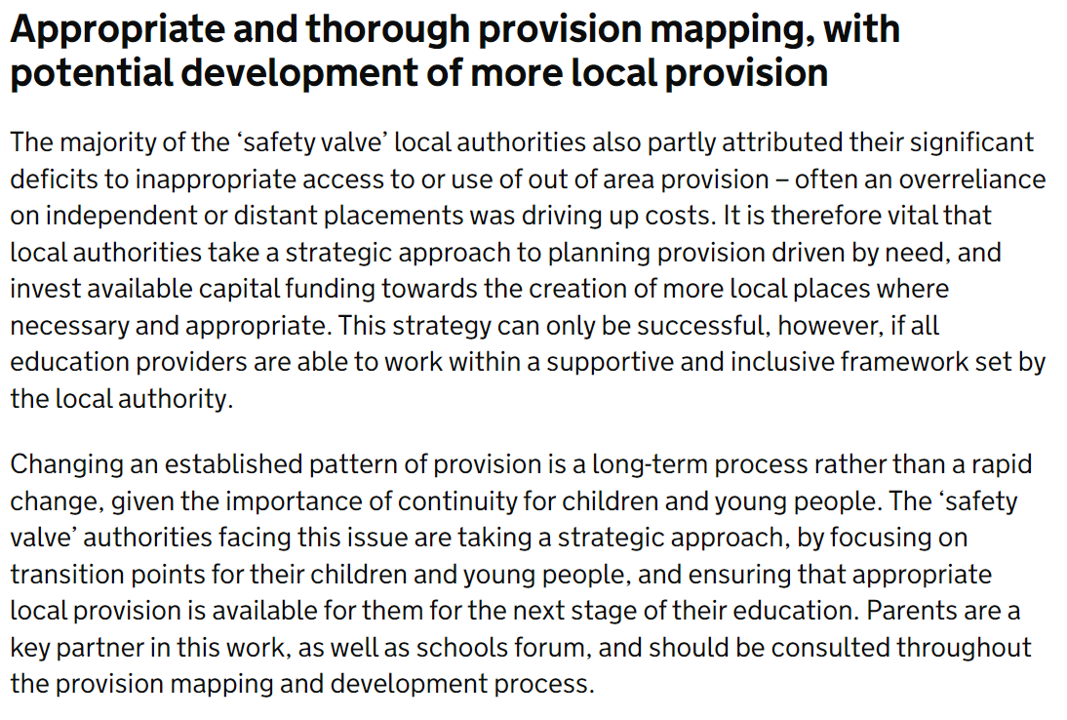
Three of these themes directly relate to the SEND Green Paper (Increased SEN Support offer, Review EHCP Assessment Process and Thresholds Culture change and work with school leaders) with the remaining themes (Early Intervention Focus, Appropriate and thorough provision mapping, with potential development of more local provision) complementing the spirit of the Green Paper. To remind, the 8 elements of the SEND Green Paper are:
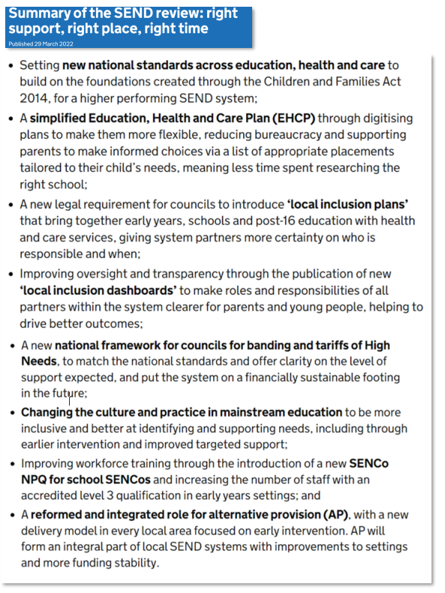
These direct links between the Safety Valve programme and SEND Green Paper suggest that the DfE are committed to implementing these in full and sustaining these over the medium/long term. Therefore, we should assume that Norfolk’s safety valve programme needs to reflect these themes also.
Norfolk’s range of SEND strategic improvement programmes, over the past 3 years, (SEND & AP Transformation Programme, Area SEND Strategy, Written Statement of Action) will move into a 2nd phase in the autumn and these already align with the themes of both the safety valve programme and SEND green paper. Therefore, we are well positioned to maximise the benefits of direct work with the DfE to address Norfolk’s remaining SEND challenges.

Actions and activity during summer and autumn
Norfolk received a formal invitation into the safety valve programme in April and we had our initial meeting with the DfE/EFSA team in May. We will be meeting regularly with them up to the 15 September when we must submit our draft plan ahead of a final plan on 6 October. The timeline over the course of the next 12 months is:

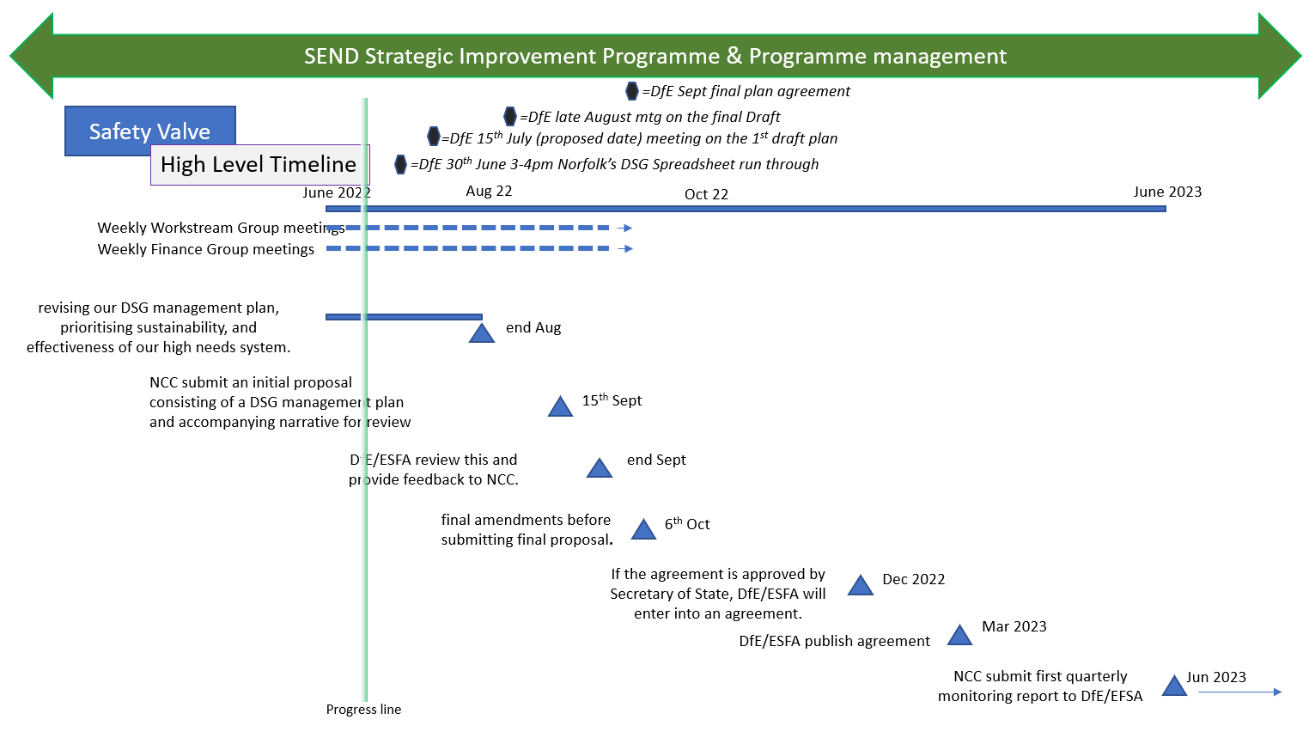

We are working at pace to develop our current Phase 2 planning, for the next stage of our SEND strategic improvement programme and to align with the Safety Valve programme. The DfE timeline dictates that we cannot share details of the plan prior to the 15 September deadline with the full Schools Forum and/or the wider school leadership community. However, we want to provide reassurance that the basis of the plan will feature the key elements of our plans to date, i.e.
- Building more specialist provision
- Reducing reliance on high cost independent sector placements
- Reducing reliance on EHCP
- Increasing support, challenge and guidance at SEN Support
- Ensuring that strategic planning within Learning & Inclusion teams in Children’s Service continue to align with plans for family support and social care, in addition to joint planning with CCG for example mental health services

Our Phase 2 plan will, however, need to be bold and go further / faster, for example we need to take advantage of our progress to date within our capital programme and actively implement the reductions in the use of high-cost placements, alongside ensuring needs can increasingly be met at SEN Support. This is fully in line with the SEND Green Paper and we will be expecting the DfE to support us in our plans.

Next Steps
We want to offer Schools Forum members the opportunity to be briefed on, and engage with, our draft plan prior to submission to DfE in September. This would require a meeting w/c 5 September.
In addition, we will provide update reports to full Schools Forum meetings in the autumn term, with the output of our final submission in October and in anticipation of formal response from the Secretary of State by end of autumn term.
Ahead of the publication of the Norfolk Safety Valve plan, by the DfE, in March 2023 we will share the detail of the plan with Schools Forum including schedules of meetings to feed into our quarterly monitoring reporting to the DfE throughout the, likely, 5 years of the programme.

Officer Contact
If you have any questions about matters contained or want to see copies of any assessments, e.g. equality impact assessment, please get in touch with:

If you have any questions about matters contained in this paper, please get in touch with:

Officer Name: Tel No: Email address:
Michael Bateman 01603 307572 michael.bateman@norfolk.gov.uk
(Assistant Director SEND Strategic Improvement and Early Effectiveness)

If you need this report in large print, audio, Braille, alternative format or in a different language please contact 0344 800 8020 or 0344 800 8011 (textphone) and we will do our best to help.

Schools Forum
Item No.4b

Report title: | DSG Management Plan Update
Date of meeting: | 8 July 2022

Executive summary
This report provides an update to Norfolk’s DSG Management Plan.

In this update:

- The plan has been updated to reflect the 2021-22 DSG outturn reported to Schools Forum at the May 2022 meeting;
- Placement costs of individual special schools and SRB’s have been updated, replacing average cost assumptions for increased accuracy of forecasting future new places;
- Inflation assumptions have been updated for independent placements.

These updates result in an increase to the overall cumulative deficit currently projected by the end of the 2025-26 financial year from £154.706m to £159.403m.

The update has not revised any of the base assumptions regarding the impact of strategies and investment to reduce escalation of need, improve outcomes for children and young people and, therefore, reduce the longer-term demand upon the High Needs Block.

In addition, no assumptions have yet been included for any potential impact of the Green Paper: SEND review: right support, right place, right time.

The LA is currently working with the DfE under the Safety Valve programme to further develop the DSG management plan and a major refresh of the plan is planned for the autumn term.

For information only. Comments from Forum are welcome, will be recorded and considered by the Local Authority.

- DSG Management Plan

1.1 Previous DSG Management Plan forecast

The previous DSG Management Plan shared with Schools Forum in January 2022, and upon which the 2022-23 budget is predicated, was based on period 8 (end of November) monitoring. This projected a DSG deficit of £154.706m by the end of the 2025-26 financial year. Further details are available in the previous January 2022 Forum papers (agenda and minutes).
Link to Schools Forum papers on website: Forum agendas and papers

1.2 Latest DSG Management Plan forecast

The DSG management plan has been updated based upon the 2021-22 financial year DSG outturn. The latest DSG management plan forecast is shown in the table overleaf.

The modelling continues to be improved and refined on an iterative basis. Some of the updates are revisions or improvements to previous figures where more accurate information is now known. In particular:

- Placement costs for individual special schools and SRB’s have been updated based on latest information;
- Inflation assumptions have been updated for independent placements.

The 2021-22 financial year DSG outturn was £22.179m overspend, which was a reduction compared to the previous DSG Management Plan forecast of £22.527m. The variances for each DSG block were detailed in the May Schools Forum meeting in the ‘DSG Final Outturn and Balances 2021-22’ paper.

As a result of the reduced outturn, the actual cumulative DSG deficit held on reserves as at 31st March 2022 reduced from the previous forecast of £54.324m to £53.976m.

Based upon the latest information available, and the updates to modelling, the cumulative DSG deficit forecast for the end of financial year 2025-26 has increased from £154.706m to £159.403m.

A reconciliation between the DSG management plan published in January 2022 and the latest plan is provided in Appendix 1.

DSG Management Plan, £m | Outturn |  |  |  | Forecast
 | 2018/19 | 2019/20 | 2020/21 | 2021/22 | 2022/23 | 2023/24 | 2024/25 | 2025/26
High Needs Block DSG Income | 80.462 | 81.917 | 93.311 | 103.840 | 114.886 | 119.564 | 122.418 | 125.343
0.5% Schools Block Transfer | 2.365 | 2.410 | 2.535 | 2.621 | 2.843 | 2.872 | 2.900 | 2.929
Additional Schools Block to High Needs Block Transfer | 0.000 | 4.580 | 0.000 | 0.000 | 5.686 | 5.743 | 5.801 | 5.859
Additional High Needs Block allocation (notified Dec 2021) |  |  |  |  | 4.350 | 4.350 | 4.350 | 4.350
Schools Block / Early Years Block / Central Services Schools Block Underspends | 4.095 | 1.491 | 0.369 | -0.498
Total Resources | 86.922 | 90.398 | 96.215 | 105.963 | 127.765 | 132.528 | 135.469 | 138.480
Placement Budget starting point |  |  | 87.103 | 93.441 | 106.111 | 120.941 | 130.820 | 138.516
Demographic Growth |  |  | 7.711 | 16.057 | 21.182 | 15.458 | 10.858 | 11.425
Savings |  |  | -1.373 | -3.388 | -6.352 | -5.579 | -3.163 | -3.639
Total Placements | 80.488 | 87.103 | 93.441 | 106.111 | 120.941 | 130.820 | 138.516 | 146.302
Exceptional Circumstances inc. Inclusion & AP | 0.396 | 1.342 | 2.205 | 4.935 | 5.277 | 5.277 | 5.277 | 5.277
EHCP/SEN Support | 5.680 | 7.420 | 7.815 | 9.992 | 10.973 | 11.723 | 12.473 | 13.223
New Special School Start-up Costs |  |  | 0.113 | 0.568 | 0.318 | 0.000 | 0.000 | 0.000
Speech and Language Therapy Service contribution | 0.771 | 1.002 | 1.004 | 1.045 | 1.068 | 1.000 | 0.970 | 0.970
Sensory Support | 1.566 | 1.565 | 1.565 | 1.565 | 1.943 | 1.943 | 1.943 | 1.943
Youth Offending Team contribution | 0.290 | 0.290 | 0.290 | 0.290 | 0.290 | 0.290 | 0.290 | 0.290
Child and Adolescent Mental Health Service contribution | 0.251 | 0.251 | 0.251 | 0.251 | 0.251 | 0.251 | 0.251 | 0.251
High Needs Inclusion Infrastructure | 0.832 | 0.854 | 1.632 | 2.026 | 2.026 | 2.026 | 2.026 | 2.026
Permanent Exclusion charges | -0.999 | -1.082 | -0.506 | -0.684 | -0.500 | -0.500 | -0.500 | -0.500
Other | 0.447 | 0.469 | 0.498 | 0.601 | 0.720 | 0.720 | 0.720 | 0.720
Health & Social Care levy |  |  |  |  | 0.500 | 0.500 | 0.500 | 0.500
Teachers' Pay Grant and Teachers' Pension Employer Contribution Grant |  |  |  | 1.443 | 1.882 | 2.059 | 2.154 | 2.251
Total Expenditure | 89.722 | 99.214 | 108.308 | 128.142 | 145.689 | 156.108 | 164.620 | 173.252
Surplus (+)/Deficit (-) | -2.800 | -8.816 | -12.093 | -22.179 | -17.924 | -23.580 | -29.151 | -34.772
Cumulative Deficit | -10.887 | -19.703 | -31.797 | -53.976 | -71.900 | -95.480 | -124.631 | -159.403

Placements Costs by type, £m: | 2018/19 | 2019/20 | 2020/21 | 2021/22 | 2022/23 | 2023/24 | 2024/25 | 2025/26
Maintained / Academy / Free Special Schools | 31.587 | 34.260 | 36.260 | 39.164 | 45.379 | 49.039 | 50.976 | 52.969
Independent Special Schools | 25.604 | 30.456 | 33.050 | 40.905 | 43.597 | 48.733 | 53.306 | 58.042
Add/Other Provisions |  |  |  |  | 2.870 | 3.370 | 3.870 | 4.370
Medical Needs/Hospital Provision |  |  |  |  | 0.684 | 0.184 | 0.184 | 0.184
Personal Budgets | 0.451 | 0.501 | 0.246 | 0.405 | 0.300 | 0.300 | 0.300 | 0.300
Section 19 Placements and Support^ | 0.000 | 0.060 | 0.938 | 1.076 | 1.174 | 1.174 | 1.174 | 1.174
Alternative Provision | 6.455 | 4.693 | 4.198 | 2.135 | 2.142 | 2.142 | 2.142 | 2.142
Post-16 (Further Education) | 6.440 | 6.774 | 7.090 | 7.582 | 7.851 | 7.987 | 8.378 | 8.799
Specialist Resource Bases & Deaf Resource Bases | 3.089 | 3.242 | 3.714 | 5.113 | 6.815 | 7.639 | 7.797 | 7.797
Short Stay Schools | 6.129 | 6.821 | 7.110 | 9.015 | 8.900 | 8.888 | 8.888 | 8.888
Other Local Authority Recoupment | 0.734 | 0.298 | 0.837 | 0.714 | 1.230 | 1.366 | 1.502 | 1.638
Total Placement Costs | 80.488 | 87.103 | 93.441 | 106.111 | 120.941 | 130.820 | 138.516 | 146.302

Placements Numbers by type: | 2018/19 | 2019/20 | 2020/21 | 2021/22 | 2022/23 | 2023/24 | 2024/25 | 2025/26
Maintained / Academy / Free Special Schools | 1,484 | 1,577 | 1,630 | 1,826 | 2,036 | 2,131 | 2,227 | 2,318
Independent Special Schools | 615 | 847 | 922 | 879 | 926 | 976 | 1,026 | 1,076
Add/Other Provisions |  |  |  | 160 | 205 | 250 | 295 | 340
Medical Needs/Hospital Provision |  |  |  | 20 | 84 | 20 | 20 | 20
Personal Budgets | 55 | 65 | 52 | 72 | 82 | 82 | 82 | 82
Section 19 Placements and Support^ |  | 83 | 33 | 135 | 157 | 157 | 157 | 157
Alternative Provision | 351 | 252 | 113 | 111 | 111 | 114 | 114 | 115
Post-16 (Further Education) | 588 | 677 | 632 | 753 | 782 | 812 | 842 | 872
Specialist Resource Bases & Deaf Resource Bases | 242 | 242 | 260 | 354 | 460 | 466 | 466 | 466
Short Stay Schools | 350 | 370 | 370 | 432 | 432 | 432 | 432 | 432
Other Local Authority Recoupment | 74 | 83 | 94 | 95 | 96 | 105 | 114 | 123
Total Placement Numbers | 3,759 | 4,196 | 4,106 | 4,837 | 5,371 | 5,545 | 5,775 | 6,001

- Future DSG Management Plan Updates

The latest update is based upon the 2021-22 DSG outturn, minor updates to placement cost assumptions, and the amendment of future inflation assumptions for independent placements within the modelling. The DSG Management Plan is an iterative document, and the LA is expected to share it with Schools Forum at least termly.

In addition to the capital investment that has been made by the LA to increase the number of specialist places both in resource bases and schools, significant work by the LA, Schools Forum and the wider system has been taking place to put in place strategies, supported by investment, to reduce escalation of need and to support children and young people to remain in mainstream schools where this is appropriate to do so. The impact of this work upon future projections can be hard to anticipate due to the complexity of the assumptions and variables, but work is being undertaken to include these projections in the Autumn refresh that will be aligned with the Safety Valve programme work.

In addition, no assumptions have yet been included for any potential impact of the national SEND review. For example, the DfE have stated in their SEND Review Green Paper that they propose the introduction of a new national framework of banding and price tariffs for high needs funding, matched to levels of need and types of education provision set out in the new national SEND standards. No detail is available yet, but the DfE state that tariffs would ensure the right pricing structures are in place, helping to control high costs attributed to expensive provision. Future updates of Norfolk’s DSG Management Plan will take these elements into account as and when further information from the DfE becomes available.

Significant assumptions included in the plan can be difficult to ascertain not just because of the demand-led nature of the spend, but also due to the differing expectations and interests of the various parties involved. Not all parties will agree with the assumptions included in the forward plan as a result.

E.g., the DfE expect the LA to return the DSG budget to a break-even position as soon as possible and advise that the use of block transfers should be considered as part of the plan. However, LAs are not able to fully control the admissions to specialist provision available where there is a shortage due to the Tribunal process, which can lead to unexpected costs and independent placements in provision that may not deliver the best outcomes, but increase costs to the HNB. The LA is also expected to prioritise paying for specialist placement costs from the HNB but need to invest in alternative support and interventions to ‘turn the tide’ on needs escalation. On the other hand, schools want to maximise the funding direct to their schools to enable them to support earlier intervention and to prevent escalation of need, which a block transfer counteracts. Finally, the LA need to produce a plan spanning a number of years, but schools and Schools Forum are consulted on an annual basis.

The LA is currently working with the DfE under the Safety Valve programme to further develop the DSG Management Plan, and a major refresh of the plan is planned for the autumn term. This includes the development of further strategies that seek to reduce the in-year deficit whilst also ensuring good outcomes for children. Further information will be shared when this is available.

Officer Contact
If you have any questions about matters contained or want to see copies of any assessments, e.g. equality impact assessment, please get in touch with:

If you have any questions about matters contained in this paper, please get in touch with:

Officer Name: Tel No: Email address:
Martin Brock 01603 223800 martin.brock@norfolk.gov.uk

If you need this report in large print, audio, Braille, alternative format or in a different language please contact 0344 800 8020 or 0344 800 8011 (textphone) and we will do our best to help.

Appendix 1: Previous DSG Management Plan (January) vs Update (July)
DSG Management Plan item | Total change between plan versions  (£m) | Comments
High Needs Block DSG Income | 0.143 | Change to forecast income over the period 2023-24 to 2025-26, due to timing changes of new places created
Schools Block/EY Block/CSS Block | 0.682 | EY Block overspend at year end, partly offset by underspends on Schools and CSS Blocks – reported in detail at May Forum
Maintained/Academy Special Schools | -0.617 | -£0.233m in 2021-22 for timing changes of new special school places (various, existing schools), £0.442m movement between independent and special forecasts (cancels out to £0 but is also separately reported on TPG/TPECG line) in relation to underspend of TPG/TPECG grants, -£0.826m for timing updates and new information on additional places in future years (new and existing schools)
Independent Special Schools | 4.841 | £5.391m for amended inflation assumptions, -£0.442m movement between independent and special forecasts (cancels out to £0, but is also separately reported on TPG/TPECG line) in relation to underspend of TPG/TPECG grants, -£0.108m for final outturn actuals vs previous commitments within forecast.
Section 19 Placements | -0.097 | Reflects clarification of offer and anticipated number supported
Alternative Provision | -0.008 | Reduction due to ceased placements
Post-16 (FE) | 0.123 | Additional pupils at year end compared to previous estimate (due to late applications/claims)
Specialist Resource Bases | 0.205 | Ongoing costs of new Secondary North ASD and existing LCN SRB places opening in 22-23 added to forecasts of future years
Personal Budgets | -0.061 | Final outturn lower than previous forecast
Short Stay School | 0.026 | Updated assumptions regarding claw backs and 1:1 costs
Other Local Authority Recoupment | -0.340 | Outturn was lower than previous plan forecast, and 12 fewer pupils, due to leavers in other LA’s
Exceptional Circumstances/Inclusion and AP | -0.152 | Reduced claims from mainstream schools at year end compared to previous forecast
EHCP/SEN Support | 0.538 | Increased claims from mainstream schools at year end, including backdated EHCP pupils not claimed for Autumn term.
Speech & Language Therapy | -0.021 | Small amendments to reflect latest information regarding expected costs
Permanent Exclusion Charges | -0.062 | Increased PEX income at year end
Other (see comments) | -0.040 | SEN Invest to save (-£0.084m due to delay of potential project work with schools re: delayed DfE SEND reforms);  DDA equipment (+£0.048m additional spend through to year end)
TPG/TPECG | -0.463 | Grant retained to offset the increased cost of independent fees (-£0.442m) and adjusted forecast of future grant based on lagged place numbers (-£0.021m)
Total increase to 2025-26 forecast deficit | 4.697 | From £154.706m to £159.403m

Schools Forum
Item No.5a

Report title: | Scheme for Financing Schools - Balances
Date of meeting: | 8 July 2022

Executive summary
This report summarises a review of the current analysis of balances mechanism within the Scheme for Financing Schools and puts forward recommendations from the Finance Consultative Group for the removal of the current exception process and contingency limits (subject to all items being fully justified within this category).
Schools Forum is asked to:
- Agree to consult schools in the Autumn Term 22 the principle of:
- Removing the exception process from the analysis of balances mechanism within the Scheme for Financing Schools;
- Removing the contingency limits, currently the greater of £20k or 8% of final budget share, from the analysis of balances mechanism within the Scheme for Financing Schools (subject to all items being fully justified within this category).
- Including a paragraph stating that “As there will be no general contingency limit, a level of redistribution will be introduced if the school cannot provide sufficient evidence to justify its surplus. The Local Authority will reserve the right where schools have consistently built up significant excessive uncommitted balances to redistribute if deemed appropriate”.

- Background and Purpose
The current ‘school balances’ mechanism has been in place since April 2013 and it is felt that it requires reviewing as a result of the evolving educational landscape. A copy of the existing Analysis of Balances form can be found at appendix A. The main area of focus is the general contingency category on the form. We do not suggest any changes to the other categories.
The current relevant section of the Scheme for Financing Schools states:
Section 4: The treatment of surplus and deficit balances arising in relation to budget shares
Section 4.2 Restrictions on carrying forward surplus balances
Within section 4.2 (d):
“With effect from 1 April 2013, surplus budget share balances held by schools as permitted under this scheme are subject to the following restrictions:”
- “the legitimate purposes that balances may be held for are:- • To provide the school with contingency funding, the amount not exceeding 8% of the final budget share or £20,000 whichever is the greater.”
- “A school by school justification for an additional exception, subject to the submission of justification data by the 28 February and approval of the exception by the Head of Finance, Leadership and Governance.”
The key factors as to why a review of the general contingency category is required are:
- 1). The £20,000 or 8% of the final budget share, whichever is greater, restriction does not meet the current needs of either schools or the LA.
- 2). The additional exception process that allows schools to protect their balances for specific projects has seen an increase in submissions over recent years.
- 3). The number of schools with high surplus balances has increased over the last few years, with uncertainty over future year funding, staffing costs and post Covid impact cited as examples as to why balances may be increasing.
The Department for Education’s statutory guidance details that it is the responsibility of LAs to determine whether a balance control mechanism is required. Further information can be found in appendix B. Schemes for financing local authority maintained schools - GOV.UK (www.gov.uk)
- Proposal
It is proposed that the Scheme for Financing schools is amended to:
- Remove the exception process from the analysis of balances mechanism within the Scheme for Financing Schools;
- Remove the contingency limits, currently the greater of £20k or 8% of final budget share, from the analysis of balances mechanism within the Scheme for Financing Schools (subject to all items being fully justified within this category).
- Include a paragraph stating that “As there will be no general contingency limit, a level of redistribution will be introduced if the school cannot provide sufficient evidence to justify its surplus. The Local Authority will reserve the right where schools have consistently built up significant excessive uncommitted balances to redistribute if deemed appropriate.”
Norfolk’s maintained schools will need to be consulted upon the proposed amendment prior to the LA making a final decision. It is proposed that the consultation takes place in the Autumn term alongside the annual Fair Funding consultation with all schools. This would allow the amendment to be made during 2022-23 and, therefore, to be implemented for the 2022-23 financial year-end.

- Impact of the Proposal

By implementing this proposal it will allow:
- A greater understanding for schools to identify their balances and provide strategic information to school governors. This would enable further scrutiny to ensure balances are being utilised in the appropriate area of the school budget at local school level.

- To streamline the process and reduce the burden on schools and LA officers by removing requirement to submit an additional exception request so this is now completed as part of the justification process for general contingency.

- Allow the Education Finance team to review the justification and ensure any sums are included in schools future year budget planning.

- Allow Learning and Inclusion colleagues to be able to request this information from the Education Finance team to support with schools under intervention, imminent Ofsted inspection and those that have submitted Element 3 requests who require financial support with their budgets. This would provide transparency of data across different departments and would enable further scrutiny to ensure balances are being utilised in the appropriate area of the school budget.

- Evidence and Reasons for Decision

Analysis has been undertaken of the current arrangements and their impact and is set out in Appendix C.
From the data analysis in table 1.1 and 1.2 it illustrates the high level of school balances confirmed for the 2021-22 financial year and the forecasted balances for 2022-23, especially those schools with balances upwards of £25k.
From the 2021-22 data return, we can acknowledge that £9.8m was recorded under the general contingency category and no justification of the funds protected were required.
There has also been an upward trend in schools utilising the additional exception process to safeguard their funds before year end has concluded.
School balances for 2022-23 are still estimated to be high as table 1.2 illustrates.
After discussions with the Finance Consultative Group, the group have recommended the proposed changes, including that schools would need to fully justify any sums that are included within this category.

- Alternative Options
Instead of agreeing to consult on the proposed changes, Schools Forum could request that consultation is undertaken upon alternative options, which could include making no change to the current arrangements or implementing alternative restrictions.

- Recommendations
Schools Forum is asked to:
- Agree to consult schools in the Autumn Term 22 the principle of:
- Removing the exception process from the analysis of balances mechanism within the Scheme for Financing Schools;
- Removing the contingency limits, currently the greater of £20k or 8% of final budget share, from the analysis of balances mechanism within the Scheme for Financing Schools (subject to all items being fully justified within this category).
- Including a paragraph stating that “As there will be no general contingency limit, a level of redistribution will be introduced if the school cannot provide sufficient evidence to justify its surplus. The Local Authority will reserve the right where schools have consistently built up significant excessive uncommitted balances to redistribute if deemed appropriate”.

Appendix A - Existing Analysis of Balances form
 |  |  |  |  |  |  |  |  | £
1 | Actual Revenue Balance Reconciled with LA:
2 | Pupil Premium sum total of balance:
 |  |  |  | Bfwd 19/20 |  |  |  | 2A
 |  |  |  | Income 20/21 |  |  |  | 2B
 |  |  |  | Expenditure 20/21 |  |  |  | 2C
 |  |  |  | Balance Cfwd 20/21
 | (This could be greater than that shown of Revenue in hand)
3 | PE Sports Premium sum total of balance:
 |  |  |  | Bfwd 19/20 |  |  |  | 3A
 |  |  |  | Income 20/21 |  |  |  | 3B
 |  |  |  | Expenditure 20/21 |  |  |  | 3C
 |  |  |  | Balance Cfwd 20/21
 | (This could be greater than that shown of Revenue in hand)
4 | Surpluses derived from sources other than the budget share:
 | (Breakdown of where monies have come from and how they are to be spent must be attached)
5 | Exceptional circumstances:
 | Schools mays use this category if an individual allocation amounting to more than 1%
 | of the final budgetshare was allocated after 1st February
 | The maximum allowable for your school £ X
6 | Additional Exception (as previously agreed):
 | (As previously agreed - this should be included as part of the Revenue in hand)
7 | Capital Building Projects - VA Schools Only:
 | (Evidence of what the monies are for, the likely start and finish date must be attached)
8 | Balance held for Community Facility operation:
 | (Information taken from I17 and E31/E32 via Consistent Financial Reporting Regulations)
9 | To be returned for redistribution to all schools:
10 | General contingency actual Revenue in Hand:
 | (Balance remaining once other sums have been accounted for)
11 | Total - This should be the total of 2-10 and agree with figure entered at 1 above:

Appendix B – Extract of Schemes for financing local authority maintained schools (www.gov.uk)
6. The treatment of surplus and deficit balances arising in relation to budget shares
6.1 Right to carry forward surplus balances
The scheme must contain a provision which allows schools to carry forward from one financial year to the next any shortfall in expenditure relative to the school’s budget share for the year plus/minus any balance brought forward from the previous year.
The scheme should explain the basis on which the amount of any balance to be transferred to a school’s bank account would be calculated on a provisional basis for a school having a new bank account, and the date by which the transfer would occur, pending a later reconciliation.
The amount of a surplus balance would be shown in the relevant outturn statement published in accordance with directions given by the Secretary of State under section 251 of the Apprenticeships, Skills, Children and Learning Act 2009; although there may be commitments against any figure shown in such a statement.
6.2 Controls on surplus balances
The scheme may contain a mechanism to claw back excess surplus balances.
Any mechanism should have regard to the principle that schools should be moving towards greater autonomy, should not be constrained from making early efficiencies to support their medium-term budgeting in a tighter financial climate, and should not be burdened by bureaucracy.
The mechanism should, therefore, be focused on only those schools which have built up significant excessive uncommitted balances or where some level of redistribution would support improved provision across a local area.

Appendix C – Data Analysis
- £20,000 or 8% of final budget share
Only 2 schools had budget shares which were less than £250,000 (both are nursery settings) and where the £20,000 would have been allowable as their general contingency. All other schools had final budget shares greater than £250,000.
The total allowable under the 8% of school’s final budget shares accounted for £14.7m of the overall surplus that could have been included under the general contingency category and this sum would not have required any justification.
The actual confirmed sum by all schools under the general contingency category, where justification would not have been required, accounted to £9.8m.
- Additional Exception
Below provides some information on the increase in number of additional exceptions submitted year-on-year:
2017-18 5
2018-19 11
2019-20 14
2020-21 30
2021-22 31
Some examples of submissions included unspent Covid catch-up funding, unspent budgets due to Covid impact, dip in pupil numbers so funding needed to be protected to support current staffing levels and specific project work.
- Surplus Balances
Below is a table illustrating the confirmed balances for 2021-22:
Table 1.1
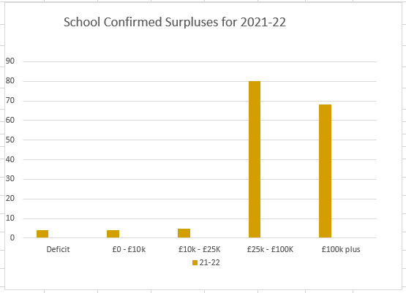

Below is a table illustrating estimated balances for 2022-23
Table 1.2

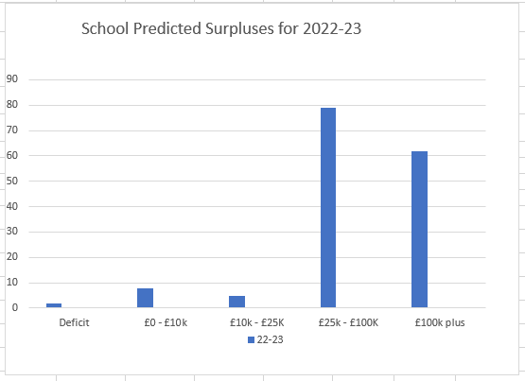

Schools Forum
Item No.5b

Report title: | Scheme for Financing Schools Updates
Date of meeting: | 8 July 2022

Executive summary
Local authorities are required to publish schemes for financing schools setting out the financial relationship between them and the schools they maintain.
Changes are periodically required based on revisions directed by the Secretary of State, or local changes approved through Schools Forum.
There are no directed revisions for 2022-23 for amendment in the local Scheme, however references to the Salix Scheme have been removed from national guidance, as this scheme has now closed.
In addition, the LA is seeking Forum’s approval to consult with schools on changes to the level of funds that can be held by schools within the School Building Maintenance holding account (in time for implementation by the 2022-23 financial year end).
Schools Forum is asked to:

- Agree to consult schools in the Autumn Term 22 the principle of:
- Removing references to the Salix Scheme from Norfolk’s Scheme for Financing Schools for 2022-23.
- Discuss the proposed increases to the limits of monies held within the School Building Maintenance holding account prior to inclusion within the autumn term fair funding consultation.

- Introduction
Local authorities are required to publish schemes for financing schools setting out the financial relationship between them and the schools they maintain.
Guidance is provided to authorities listing the items that must, should or may be included, and is issued under the School Standards and Framework Act 1998.
The local scheme is updated in the following circumstances:
- Directed revisions – the Secretary of State may require the revision of part or any scheme. These revisions must be included in the local scheme using the text of the directed revisions;

- Amendments to directed revisions – amendments to the wording of directed revisions may be required to reflect more recent policy positions;
- Local revisions – for changes other than directed revisions, local authorities must consult with all maintained schools in their area and receive approval of Schools Forum members representing maintained schools.
There are no directed revisions for 2022-23 for amendment in the local Scheme, however references to the Salix Scheme have been removed from national guidance, as this scheme has now closed.

In addition, the LA is seeking Forum’s approval to consult with schools on changes to the level of funds that can be held by schools within the School Building Maintenance holding account (in time for implementation by the 2022-23 financial year end).

- Updates required

2.1 Change to national guidance – Salix Scheme

Section - 3.6, Borrowing by schools

Extract of current wording: “…Schools may use any scheme that the Secretary of State has said is available to schools without specific approval, currently including the Salix scheme, which is designed to support energy saving.”

Proposed wording: “…Schools may use any scheme that the Secretary of State has said is available to schools without specific approval.”

If agreed through consultation, this revision will be updated in Norfolk’s Scheme for Financing Schools and an updated version of the document will be uploaded onto the Norfolk Schools Website at the following link:

https://www.schools.norfolk.gov.uk/school-finance/scheme-for-financing-schools

2.2 Local revision – School Building Maintenance holding account

The Local Authority wishes to consult with maintained schools on proposed changes to the limits of monies lodged into the School Maintenance holding account. If Schools Forum agrees, the proposals would be consulted upon alongside Norfolk’s autumn Fair Funding consultation and, if subsequently approved by Schools Forum based on consultation feedback from schools, it is intended that the increased limits should be implemented in time for the 2022-23 financial year-end.

Current arrangements

Schools that do not contract into the maintenance contract of the Building Maintenance Partnership (BMPP) may make a request to the School Finance Team to lodge a sum from their schools’ year-end balances with the Local Authority. Those that buy into the compliance only BMPP offer can contribute to the School Building Maintenance Holding Account. This sum is solely for use towards building maintenance works that would be covered if the school did contract into the BMPP.

The current limit for monies lodged into the Schools Building Maintenance holding account is up to a maximum of £250,000 or £450 per pupil, whichever is the lower.

Proposed amendments

The LA proposes to amend the scheme to make an additional allowance so that those schools with community assets that are required to have a sinking fund for regular repair and maintenance of those assets e.g. swimming pools, Multi-Use Games Areas (MUGAs) etc, may also lodge funds in Schools Building Maintenance Holding Account.

These funds will be ring-fenced for repair and maintenance of the community asset and may be in addition to any standard Schools Building Maintenance funds already lodged. The amount lodged will be dependent upon sums necessary to carry out repairs and maintenance on the asset.

In addition, due to the current limits having not been revised since the introduction of the scheme, it is proposed to increase the limits for monies lodged into the Schools Building Maintenance holding account as follows:

- For mainstream schools that do not contract into BMPP the total amount lodged should be up to a maximum of £650 per pupil on roll at the time of the previous October Census, or £360,000, whichever is the lower.

- For special schools that do not contract into BMPP the total amount lodged can be up to a maximum of £815 per place at the time of the previous October Census.

Once lodged, funds cannot be returned to the school. The funds can only be used to fund building maintenance expenditure.

The proposed wording changes to the local scheme are as follows for section 4.2 (e) - ‘Restrictions on carrying forward surplus balances’:

Current wording: “schools not in the maintenance contract (Full Membership) of the Building Maintenance Partnership scheme (BMP5) may lodge monies with the Local Authority up to a maximum of £250,000 or £450 per pupil whichever is the lower (i.e. schools purchasing the BMP Compliance Only membership may lodge monies with the Local Authority for maintenance). This money will be released at any time on production of an appropriate invoice for maintenance or building work that would have been covered by the BMP5 scheme. Interest will be payable on monies lodged in this way. Funds lodged must be transferred before the financial year-end, or they will be deemed to be part of the school’s surplus balance for the purposes of the analysis of balances mechanism.

Proposed wording: “schools not in the maintenance contract (Full Membership) of the Building Maintenance Partnership Pool (BMPP) may lodge monies with the Local Authority up to a specified maximum value depending on school type:

For mainstream schools, £650 per pupil on roll at the time of the previous October Census, or £360,000, whichever is the lower.

For Special schools, £815 per place at the time of the previous October Census.

(i.e. schools purchasing the BMPP Compliance Only membership may lodge monies with the Local Authority for maintenance).

This money will be released at any time on production of an appropriate invoice for maintenance or building work that would have been covered by the BMPP scheme. Interest will be payable on monies lodged in this way. Funds lodged must be transferred before the financial year-end, or they will be deemed to be part of the school’s surplus balance for the purposes of the analysis of balances mechanism.

In addition to the limits above, schools with community assets that are required to have a sinking fund for regular repair and maintenance of those assets e.g. swimming pools, Multi-Use Games Areas (MUGAs) etc, may also lodge funds in Schools Building Maintenance Holding Account.

These funds will be ring-fenced for repair and maintenance of the community asset and may be in addition to any standard Schools Building Maintenance funds already lodged. The amount lodged will be dependent upon sums necessary to carry out repairs and maintenance on the asset.”

Schools Forum is asked to:

- Agree to consult schools in the Autumn Term 22 the principle of:

- Removing references to the Salix Scheme from Norfolk’s Scheme for Financing Schools for 2022-23.

- Discuss the proposed increases to the limits of monies held within the School Building Maintenance holding account prior to inclusion within the autumn term fair funding consultation.

Officer Contact
If you have any questions about matters contained or want to see copies of any assessments, e.g. equality impact assessment, please get in touch with:

If you have any questions about matters contained in this paper please get in touch with:

Officer Name: Tel No: Email address:
Martin Brock 01603 223800 martin.brock@norfolk.gov.uk

If you need this report in large print, audio, Braille, alternative format or in a different language please contact 0344 800 8020 or 0344 800 8011 (textphone) and we will do our best to help.

SCHOOLS FORUM FORWARD PLAN
I – Information D- Decision

 | Autumn Term |  |  | Spring Term |  |  | Summer Term
29/09/21  (Wed)  09:00 – 12:30 | September (MS-Teams)  Dedicated Schools Grant  - SEND Strategic Improvement (inc. Capital update)  - Special Schools’ Funding Review  - Indicative DSG/Schools Block Fair Funding Consultation | D  D | 19/01/22  (Wed)  09:00 – 12:30 | January (MS-Teams)  Election of Chair/Vice Chair  Review Membership  Proposed Schools Budget including central costs  Estimated Pupil variations 2022-23  Possible school closure – APT adjustment required | D  I/D  D  I  D | 18/05/22  (Wed)  09:00 – 12:00 | May (Mattishall)  Renewal of Group Catering Contract  Dedicated Schools Grant  - Dedicated Schools Grant 2021/22 Outturn  - Safety Valve  - Outcome of national SEND review/Green Paper | I/D  I  I  I
17/11/21  (Wed)  09:00 – 12.30 | November (MS-Teams)  Dedicated Schools Grant  - Early Years Block  - De-delegation/CSS Block  - Schools Block (inc. consultation, Schools Block transfer & update to DSG Recovery Plan)  - Special Schools Review (consultation) | D  D  D  I/D | 16/03/22  (Wed)  09:15 – 11:45 | March (MS-Teams)  Agree next year’s plan  Final pupil variations  Decarbonisation  Updates on Scheme for Financing Schools  (Financial Regulations) | D  I  D  D | 08/07/22  (Friday)  09:00 – 12:00 | July (Mattishall)  MyOracle Update  DSG Safety Valve/DSG Management Plan  Consultation on Scheme Changes  Appointment of Vice Chair for future meetings | I  I  D  D

SCHOOLS FORUM FORWARD PLAN
I – Information D- Decision

 | Autumn Term |  |  | Spring Term |  |  | Summer Term
30/9/22  (Friday)  09:00 – 12:00 | September (Face-to-face, venue TBC)  Indicative DSG/Schools Block Fair Funding Consultation  Early Years Funding Consultation  Central Schools Block, info on LA central teams  DSG Safety Valve | D  D  I  I | 27/01/23  (Friday)  09:00 – 12:00 | January (Remote/Venue TBC)  Election of Chair/Vice Chair  Review Membership  Proposed Schools Budget including central costs  Estimated Pupil variations 2023-24  DSG Safety Valve | D  I/D  D  I  I | 17/05/23  (Wed)  09:00 – 12:00 | May (Remote/Venue TBC)  Dedicated Schools Grant 2022/23 Outturn  Annual Audit Report (Norfolk Audit Service)  DSG Safety Valve | I  I  I
16/11/22  (Wed)  09:00 – 13:00 | November (Face-to-face, venue TBC)  DSG Management Plan  Early Years Block  De-delegation/CSS Block  Schools Block (inc. consultation outcomes and, if necessary, Schools Block transfer)  DSG Safety Valve | I  D  D  D  I | 15/03/23  (Wed)  09:00 – 12:00 | March (Remote/Venue TBC)  Agree next year’s plan  Final pupil variations  DSG Safety Valve | D  I  I | 07/07/23  (Friday)  09:00 – 12:00 | July (Remote/Venue TBC)  DSG Management Plan  Updates on Scheme for Financing Schools  (Financial Regulations)  DSG Safety Valve | I  D  I

All figures provided are rounded to 3 decimal places
SEND review: right support, right place, right time - GOV.UK (www.gov.uk)
The Finance Consultative Group is representative of Norfolk’s maintained schools
The current Scheme for Financing Schools online has not been updated since 2020-21 due to there being no directed or local revisions required.
Based on inflation calculated since introduction of the scheme, and a higher rate for special schools based on building maintenance costs per m2 from View My Financial Insights DfE toolkit (approximately 25% higher than for mainstream schools due to more complex sites than for mainstream schools of the same size).

