To access the online service, it will be necessary to have internet access and a unique User Id.
PLEASE DO NOT SHARE USER ID’s

- If you are new to using the portal and do not have a User Id, please email fis@norfolk.gov.uk.
- If someone already has access, please ask them to complete a Userid eForm (Forms Module).

The link to the online service is – www.norfolk.gov.uk/eyproviderportal

Once the link has been inserted into your browser the following page will appear –
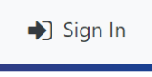
Click to Sign In

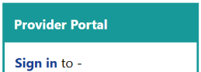
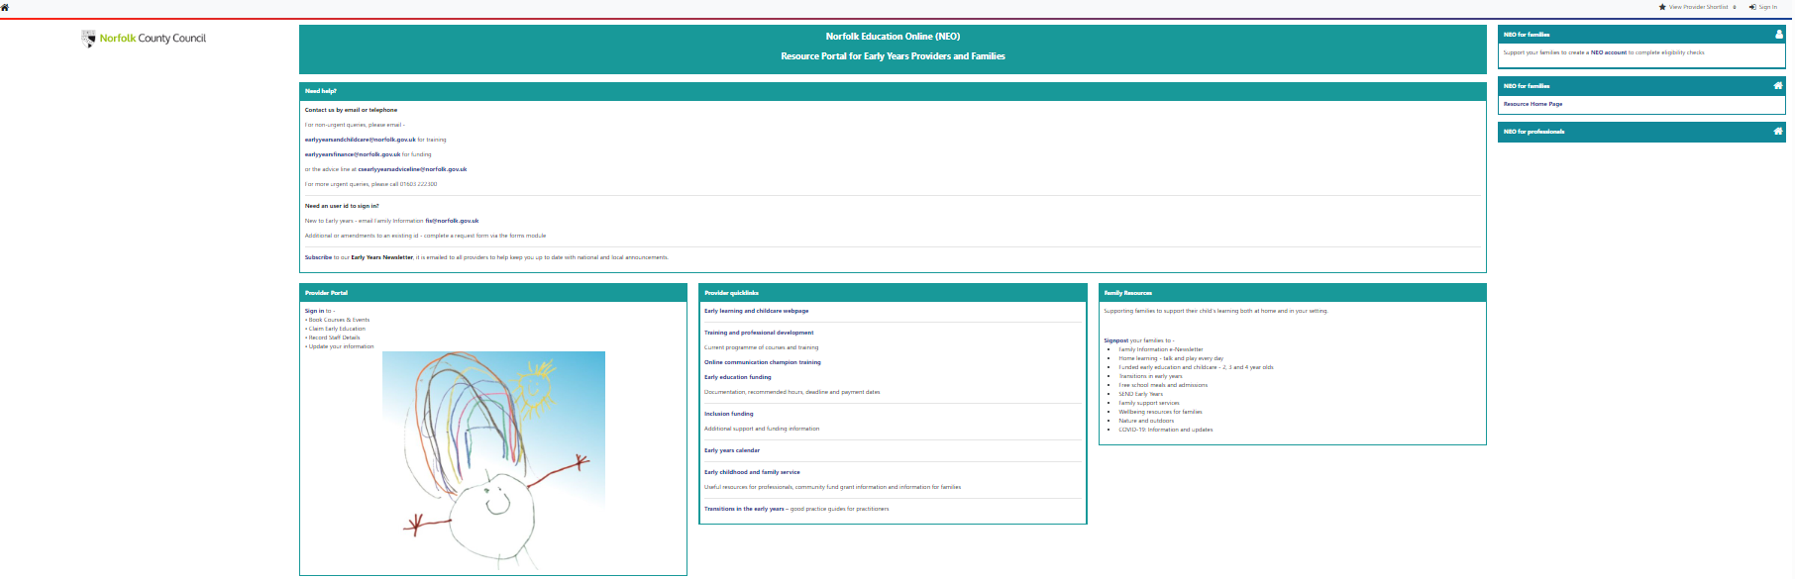

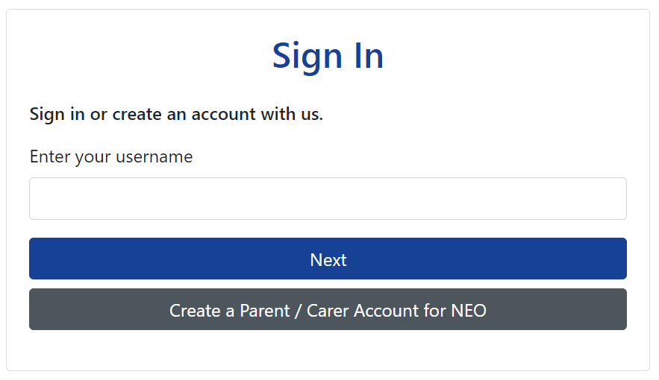
Enter your username, and click the Next button

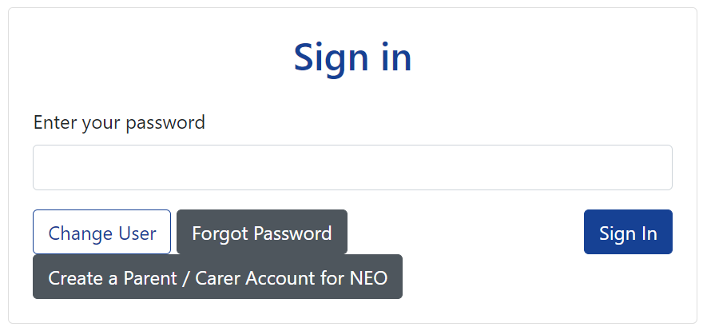
Insert your password, and click Sign In button
(you may be required to reset your password)
If your username is linked to more than organisation, select and click PROCEED
Your session will TIME OUT, where activity is not detected. Routinely save your updates to avoid any data loss.

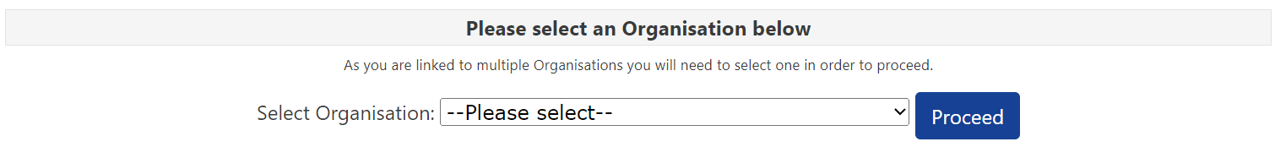

The home page will then appear –

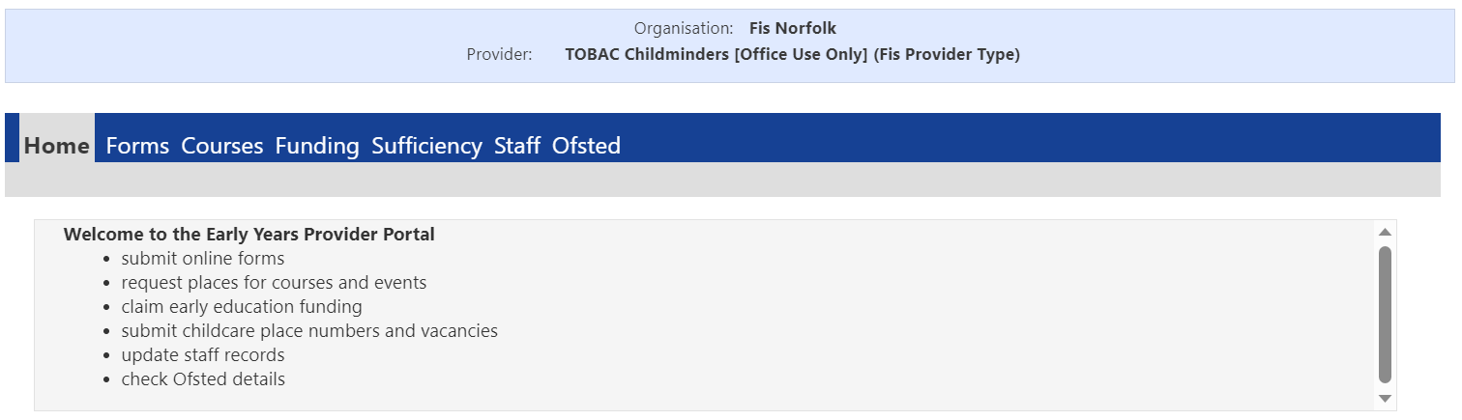

Password
To request a new password, click -

To Sign Out
If you wish to sign out, click your initials and select SIGN OUT

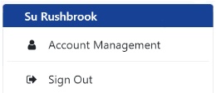
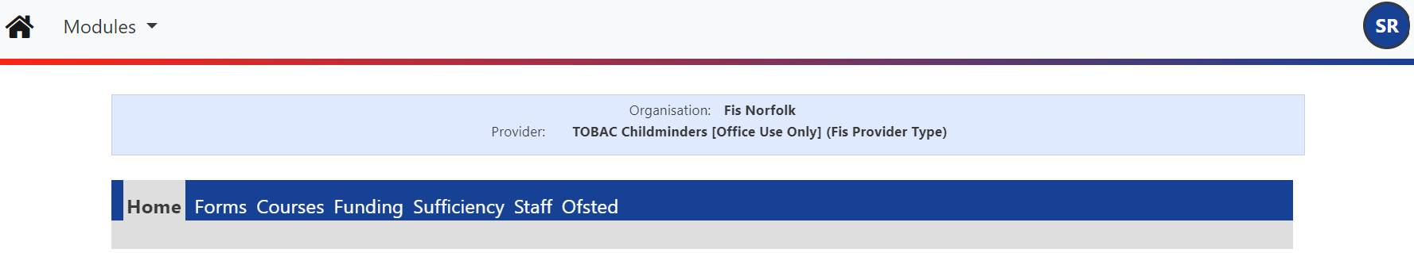

Desktop shortcut

Top Tips!

- Subscribe to our newsletters, so that you are kept up to date about the provider portal.
- Ensure your records are maintained termly.
- For system security, review termly access to the portal and use the PORTAL – Userid eForm to add, amend or delete an individual’s access.

Need Help!

Call the Advice Line on 01603 222300

To create a desktop shortcut –

Click the link and without releasing, drag to a space on your desktop

