School Balances Analysis Review
Norfolk’s Scheme for Financing Schools contains a Revenue Balance Analysis mechanism, that all LA maintained schools are required to undertake after the closedown of the financial year. The aim of the mechanism is to encourage schools to spend the funding received on the pupils in school each year and not to build up too large unplanned surpluses, unless they are for a specific pre-planned educational purpose.
Current Balance Control Mechanism
Legitimate purposes that balances may be held for are:-
• To provide the school with contingency funding, the amount not exceeding 8% of the final budget share or £20,000 whichever is the greater.
• Surpluses derived from sources other than the budget share e.g. contributions from parents for school trips where expenditure will not be incurred until the following year or surpluses arising from providing community facilities
• In exceptional circumstances with authorisation of the Finance Business Partner (Children’s Services), where an individual allocation amounting to more than 1% of the final budget share and was allocated after the 1st February.
• Voluntary Aided schools are allowed to hold revenue monies to fund governors’ liabilities towards DfE grant aided capital works. Evidence of the cost and timing of the project will be required to support this.
• Surpluses derived from Pupil Premium funding - this would mean that, for the purposes of calculating the contingency sum of 8% of the final budget share, the Pupil Premium would be excluded, but would be shown as a separate category in its’ own right.
• The amount of Pupil Premium allowed to be carried forward should not exceed the sum received in that financial year.
• The Analysis of Surplus Revenue Balances form would be pre-populated, after the year-end closure of accounts, with the maximum sum allowed under this category for each school.
• A school by school justification for an additional exception, subject to the submission of justification data by the 28 February and approval of the exception by the Head of Finance, Leadership and Governance.
Any balances falling outside these categories will be returned to the Authority for redistribution to schools. The actual balances each school has at the end of 2020/21 and subsequent financial years will be analysed and any surplus over and above monies falling into one of the legitimate categories above will be redistributed in the following financial year.
Additional categories
There are three other main areas where surplus funds may be held:
The first is part of the balance control mechanism, which is the additional exception process and must be completed by the 28th February deadline. This enables schools to lodge funds in exceptional circumstances, e.g. where expected cost pressures are likely to occur in the following year. This could be linked to requiring additional staff at the start of an academic year due to pupil number increase but funds for those children will not be received until the following April due to a funding lag. Also, where schools have a temporary dip in pupil numbers, rather than undertake a staff reduction, schools could request that they reserve the funds to support the drop to maintain their staffing levels.
The second area is linked to schools who are not part of the Building Maintenance Partnership Pool. Schools not in (BMPP) may lodge monies with the Local Authority up to a maximum of £250,000 or £450 per pupil whichever is the lower. This money will be released at any time on production of an appropriate invoice for maintenance or building work that would have been covered by the BMPP scheme. Interest will be payable on monies lodged in this way. Funds lodged must be transferred before the financial year-end, or they will be deemed to be part of the school’s surplus balance for the purposes of the analysis of balances mechanism.
The third area enables schools to transfer funds to capital where a revenue to capital contribution is required. Again, a deadline of 28th February is in place. Those schools wishing to contribute may transfer to capital up to but not exceeding the amount of capital spent in year with no governor approval and can be actioned at any time. This is very unlikely based on reducing capital grants received – therefore a revenue contribution to capital must be approved and recorded in the minutes by governors for a transfer to take place.
The LA also allow schools to carry forward any unspent PE Sports Premium Grant if this falls within current DfE guidelines. Currently the DfE conditions of grant document requires any under-spends carried forward to be spent in full by 31 March 2021. There is a concern that this may create some issues for those schools that are unable to spend the grant appropriately within the DfE deadline.

Balance mechanism issues raised by schools
A very few schools have so far raised queries regarding the justification of their revenue balance as at 31 March 2021. They are seeking assurance regarding the current situation and looking to ensure there will be no re-distribution of funds by stating the current extreme cost pressures would impact on schools and lead to them not being able to justify their balances.

Below is the latest information on school balances based on their revision 1 (July 2020) surpluses. This will not include any of the Covid-19 related grant income – Furlough Income, Exceptional Circumstances Funding or Catch-Up Funding as these were not released until after the school revision 1 had been submitted.

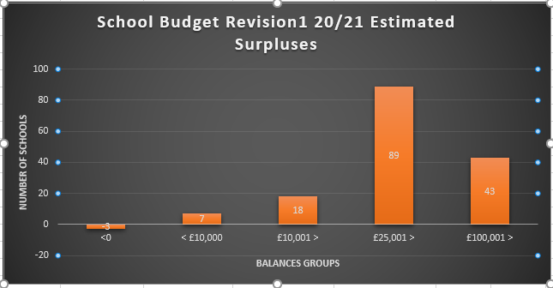

Covid-19 Grants Update
Furlough - At the peak of staff furlough there was a maximum of 27 schools that have furloughed staff which totals £218,546 between March to September. September’s data only recorded 15 schools. Staff furloughed were those assigned to before and afterschool clubs, catering & early years.
Exceptional Covid-19 Cost Fund Claims – In Norfolk a total of £448,231 has been paid out to schools based on the claims they submitted directly to the DfE. Further payments may be issued as the fourth category “other” is still being directly assessed by the DfE. The first three categories were automatically paid if schools kept within the claim levels of each category for the size of the entity as this was based on pupil numbers.

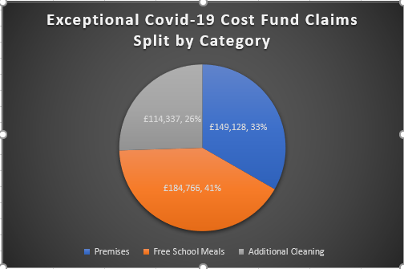
Additional Information
Whilst undertaking revision 2 budgets (due Dec 2020), it has become apparent that the majority of schools have inevitably been incurring additional cost pressures, for example:
- Energy Costs (associated with creating a ventilated environment but having to provide additional heating)
- Cleaning costs (associated with staff costs, cleaning materials etc)
- Additional Teaching Assistant costs to maintain bubbles
- IT costs to deliver remote working where required
- Catering costs – unavoidable due to government procurement policy guidelines but this ended on the 31st October 2020.
- Number of means-tested Free School Meals rising in Norfolk could result in issues for schools as they will need to provide a free meal with no additional income.
- Not all children either in school or opting for a UIFSM on October census day which would result in the school receiving a reduced amount of funding.
Finance Service staff however also noticed additional cost savings, for example:
- Savings on training costs
- Supply cost reductions linked to release time for training
- Education materials and equipment reductions
NB Some of the cost savings listed above may need to be added to future year cost projections as additional and on-going professional development may need to be accelerated to compensate for lost training during the pandemic
Some schools, particularly the larger ones, have seen a reduction in lettings income due to their facilities not being able to provide hire usage outside of school hours. Loss of lettings income must be managed by the school as there is no DfE grant to support this.
We have also experienced pupil numbers drop in several schools due to parents taking pupils out of school (or not starting in reception class) to home educate. This will undoubtably have an impact on future year income.
Conclusions
Schools who are monitoring and managing their budgets effectively through the year will be aware of their year-end balance and can be planning accordingly based on their circumstances to ensure their balances are protected following the guidance above.
The balance control mechanism was discussed at Finance Consultative Group and there was a general consensus that the current mechanism is still fit for purpose and should remain. However, it was agreed that it would be beneficial to remind schools of the current guidance as listed at the beginning of this paper.

Potential amendments to current mechanism – based on schools requiring to roll forward training costs to next year which may impact on future budgets, it may be wise to consider allowing for the carry-forward of any unspent training budgets if schools are not able to justify their balance within the guidance above?
In addition, there will be so many permutations from school to school on specific impacts of Covid-19 that the Finance team anticipate they would need to deal with them on a case by case scenario. Designated Finance Support Officers will provide guidance to schools on all the aspects discussed above and raise any concerns with their line manager.
Ring-fenced grants
As can be seen from the paper, the biggest area of concern was the potential for schools to be unable to appropriately spend the ring-fenced grants, particularly Sports Premium, within the published DfE deadline. It may therefore for the LA to lobby the DfE to attempt to defer the deadline due to the pandemic.
Schools Finance Team
November 2020

